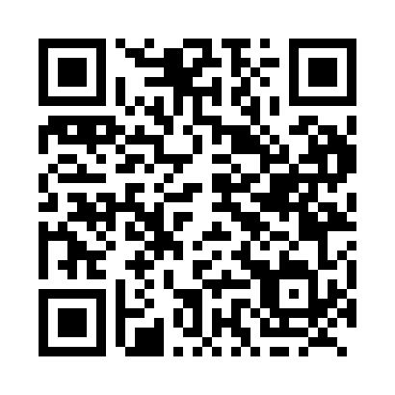
Prayer times for Hare Bay, Newfoundland and Labrador, Canada
Wed 1 May 2024 - Fri 31 May 2024
High Latitude Method: Angle Based Rule
Prayer Calculation Method: Islamic Society of North America
Asar Calculation Method: Hanafi

Date | Day | Fajr | Sunrise | Dhuhr | Asr | Maghrib | Isha
1 | Wed | 3:59 | 5:45 | 1:03 | 6:08 | 8:22 | 10:09
2 | Thu | 3:56 | 5:43 | 1:03 | 6:09 | 8:24 | 10:11
3 | Fri | 3:54 | 5:41 | 1:03 | 6:09 | 8:25 | 10:13
4 | Sat | 3:52 | 5:40 | 1:03 | 6:10 | 8:27 | 10:15
5 | Sun | 3:49 | 5:38 | 1:03 | 6:11 | 8:28 | 10:18
6 | Mon | 3:47 | 5:37 | 1:03 | 6:12 | 8:30 | 10:20
7 | Tue | 3:44 | 5:35 | 1:03 | 6:13 | 8:31 | 10:22
8 | Wed | 3:42 | 5:34 | 1:03 | 6:14 | 8:32 | 10:24
9 | Thu | 3:40 | 5:32 | 1:03 | 6:15 | 8:34 | 10:27
10 | Fri | 3:37 | 5:31 | 1:03 | 6:15 | 8:35 | 10:29
11 | Sat | 3:35 | 5:29 | 1:03 | 6:16 | 8:37 | 10:31
12 | Sun | 3:33 | 5:28 | 1:02 | 6:17 | 8:38 | 10:34
13 | Mon | 3:30 | 5:26 | 1:02 | 6:18 | 8:39 | 10:36
14 | Tue | 3:28 | 5:25 | 1:02 | 6:19 | 8:41 | 10:38
15 | Wed | 3:26 | 5:24 | 1:03 | 6:19 | 8:42 | 10:40
16 | Thu | 3:24 | 5:22 | 1:03 | 6:20 | 8:43 | 10:43
17 | Fri | 3:21 | 5:21 | 1:03 | 6:21 | 8:45 | 10:45
18 | Sat | 3:19 | 5:20 | 1:03 | 6:22 | 8:46 | 10:47
19 | Sun | 3:17 | 5:19 | 1:03 | 6:23 | 8:47 | 10:49
20 | Mon | 3:15 | 5:18 | 1:03 | 6:23 | 8:48 | 10:52
21 | Tue | 3:13 | 5:16 | 1:03 | 6:24 | 8:50 | 10:54
22 | Wed | 3:11 | 5:15 | 1:03 | 6:25 | 8:51 | 10:56
23 | Thu | 3:09 | 5:14 | 1:03 | 6:25 | 8:52 | 10:58
24 | Fri | 3:08 | 5:13 | 1:03 | 6:26 | 8:53 | 10:58
25 | Sat | 3:08 | 5:12 | 1:03 | 6:27 | 8:54 | 10:59
26 | Sun | 3:07 | 5:11 | 1:03 | 6:28 | 8:56 | 11:00
27 | Mon | 3:07 | 5:11 | 1:03 | 6:28 | 8:57 | 11:00
28 | Tue | 3:07 | 5:10 | 1:04 | 6:29 | 8:58 | 11:01
29 | Wed | 3:06 | 5:09 | 1:04 | 6:30 | 8:59 | 11:01
30 | Thu | 3:06 | 5:08 | 1:04 | 6:30 | 9:00 | 11:02
31 | Fri | 3:06 | 5:07 | 1:04 | 6:31 | 9:01 | 11:02
Prayer times provided by https://www.salahtimes.com

