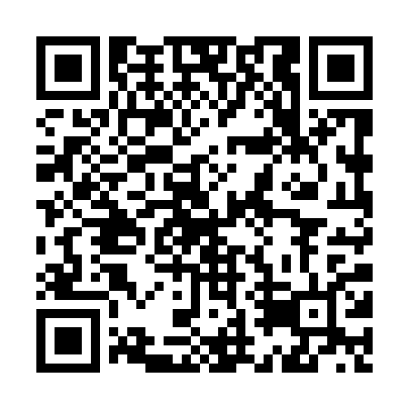
Prayer times for Johor Bahru, Malaysia
Wed 1 May 2024 - Fri 31 May 2024
High Latitude Method: None
Prayer Calculation Method: JAKIM
Asar Calculation Method: Shafi

Date | Day | Fajr | Sunrise | Dhuhr | Asr | Maghrib | Isha
1 | Wed | 5:46 | 6:57 | 1:02 | 4:22 | 7:07 | 8:19
2 | Thu | 5:45 | 6:57 | 1:02 | 4:22 | 7:07 | 8:19
3 | Fri | 5:45 | 6:57 | 1:02 | 4:23 | 7:07 | 8:19
4 | Sat | 5:45 | 6:57 | 1:02 | 4:23 | 7:07 | 8:19
5 | Sun | 5:45 | 6:57 | 1:02 | 4:23 | 7:07 | 8:19
6 | Mon | 5:45 | 6:56 | 1:02 | 4:23 | 7:07 | 8:19
7 | Tue | 5:44 | 6:56 | 1:02 | 4:23 | 7:07 | 8:19
8 | Wed | 5:44 | 6:56 | 1:01 | 4:23 | 7:07 | 8:19
9 | Thu | 5:44 | 6:56 | 1:01 | 4:24 | 7:07 | 8:19
10 | Fri | 5:44 | 6:56 | 1:01 | 4:24 | 7:07 | 8:19
11 | Sat | 5:44 | 6:56 | 1:01 | 4:24 | 7:07 | 8:19
12 | Sun | 5:43 | 6:56 | 1:01 | 4:24 | 7:07 | 8:19
13 | Mon | 5:43 | 6:56 | 1:01 | 4:24 | 7:07 | 8:20
14 | Tue | 5:43 | 6:56 | 1:01 | 4:25 | 7:07 | 8:20
15 | Wed | 5:43 | 6:56 | 1:01 | 4:25 | 7:07 | 8:20
16 | Thu | 5:43 | 6:56 | 1:01 | 4:25 | 7:07 | 8:20
17 | Fri | 5:43 | 6:56 | 1:01 | 4:25 | 7:07 | 8:20
18 | Sat | 5:43 | 6:56 | 1:01 | 4:25 | 7:07 | 8:20
19 | Sun | 5:43 | 6:56 | 1:02 | 4:26 | 7:07 | 8:21
20 | Mon | 5:42 | 6:56 | 1:02 | 4:26 | 7:07 | 8:21
21 | Tue | 5:42 | 6:56 | 1:02 | 4:26 | 7:07 | 8:21
22 | Wed | 5:42 | 6:56 | 1:02 | 4:26 | 7:07 | 8:21
23 | Thu | 5:42 | 6:56 | 1:02 | 4:26 | 7:08 | 8:21
24 | Fri | 5:42 | 6:56 | 1:02 | 4:27 | 7:08 | 8:22
25 | Sat | 5:42 | 6:56 | 1:02 | 4:27 | 7:08 | 8:22
26 | Sun | 5:42 | 6:56 | 1:02 | 4:27 | 7:08 | 8:22
27 | Mon | 5:42 | 6:56 | 1:02 | 4:27 | 7:08 | 8:22
28 | Tue | 5:42 | 6:56 | 1:02 | 4:28 | 7:08 | 8:22
29 | Wed | 5:42 | 6:57 | 1:02 | 4:28 | 7:08 | 8:23
30 | Thu | 5:42 | 6:57 | 1:03 | 4:28 | 7:09 | 8:23
31 | Fri | 5:42 | 6:57 | 1:03 | 4:28 | 7:09 | 8:23
Prayer times provided by https://www.salahtimes.com

