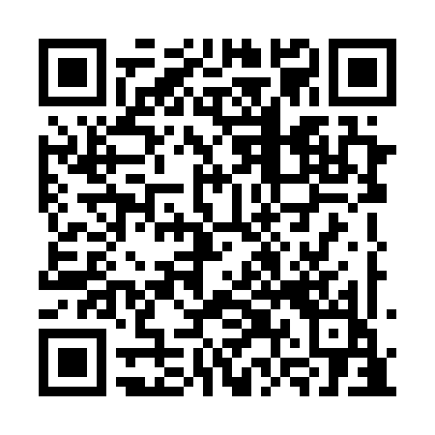
Prayer times for Uchasumaku Pikwayipanan, Quebec, Canada
Wed 1 May 2024 - Fri 31 May 2024
High Latitude Method: Angle Based Rule
Prayer Calculation Method: Islamic Society of North America
Asar Calculation Method: Hanafi

Date | Day | Fajr | Sunrise | Dhuhr | Asr | Maghrib | Isha
1 | Wed | 2:49 | 4:57 | 12:41 | 5:55 | 8:27 | 10:34
2 | Thu | 2:48 | 4:55 | 12:41 | 5:56 | 8:29 | 10:35
3 | Fri | 2:47 | 4:52 | 12:41 | 5:57 | 8:31 | 10:36
4 | Sat | 2:46 | 4:50 | 12:41 | 5:58 | 8:33 | 10:37
5 | Sun | 2:45 | 4:48 | 12:41 | 6:00 | 8:35 | 10:38
6 | Mon | 2:44 | 4:46 | 12:41 | 6:01 | 8:37 | 10:39
7 | Tue | 2:42 | 4:44 | 12:41 | 6:02 | 8:39 | 10:40
8 | Wed | 2:41 | 4:41 | 12:41 | 6:03 | 8:41 | 10:41
9 | Thu | 2:40 | 4:39 | 12:41 | 6:04 | 8:43 | 10:42
10 | Fri | 2:39 | 4:37 | 12:41 | 6:06 | 8:45 | 10:43
11 | Sat | 2:38 | 4:35 | 12:41 | 6:07 | 8:47 | 10:44
12 | Sun | 2:37 | 4:33 | 12:41 | 6:08 | 8:49 | 10:45
13 | Mon | 2:36 | 4:31 | 12:41 | 6:09 | 8:51 | 10:46
14 | Tue | 2:35 | 4:29 | 12:41 | 6:10 | 8:53 | 10:47
15 | Wed | 2:34 | 4:27 | 12:41 | 6:11 | 8:55 | 10:48
16 | Thu | 2:33 | 4:26 | 12:41 | 6:12 | 8:57 | 10:49
17 | Fri | 2:32 | 4:24 | 12:41 | 6:13 | 8:59 | 10:50
18 | Sat | 2:32 | 4:22 | 12:41 | 6:14 | 9:01 | 10:51
19 | Sun | 2:31 | 4:20 | 12:41 | 6:15 | 9:02 | 10:52
20 | Mon | 2:30 | 4:19 | 12:41 | 6:16 | 9:04 | 10:53
21 | Tue | 2:29 | 4:17 | 12:41 | 6:17 | 9:06 | 10:54
22 | Wed | 2:28 | 4:15 | 12:41 | 6:18 | 9:08 | 10:55
23 | Thu | 2:28 | 4:14 | 12:41 | 6:19 | 9:09 | 10:55
24 | Fri | 2:27 | 4:12 | 12:41 | 6:20 | 9:11 | 10:56
25 | Sat | 2:26 | 4:11 | 12:41 | 6:21 | 9:13 | 10:57
26 | Sun | 2:26 | 4:09 | 12:41 | 6:22 | 9:14 | 10:58
27 | Mon | 2:25 | 4:08 | 12:42 | 6:23 | 9:16 | 10:59
28 | Tue | 2:24 | 4:07 | 12:42 | 6:24 | 9:17 | 11:00
29 | Wed | 2:24 | 4:05 | 12:42 | 6:25 | 9:19 | 11:01
30 | Thu | 2:23 | 4:04 | 12:42 | 6:25 | 9:20 | 11:01
31 | Fri | 2:23 | 4:03 | 12:42 | 6:26 | 9:22 | 11:02
Prayer times provided by https://www.salahtimes.com

