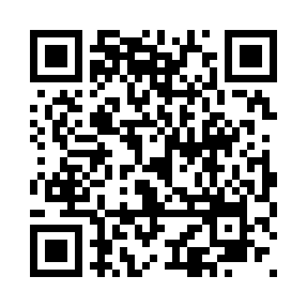
Prayer times for Edzo, Northwest Territories, Canada
Wed 1 May 2024 - Fri 31 May 2024
High Latitude Method: Angle Based Rule
Prayer Calculation Method: Islamic Society of North America
Asar Calculation Method: Hanafi

Date | Day | Fajr | Sunrise | Dhuhr | Asr | Maghrib | Isha
1 | Wed | 3:33 | 5:23 | 1:41 | 7:04 | 10:01 | 11:51
2 | Thu | 3:31 | 5:20 | 1:41 | 7:05 | 10:04 | 11:53
3 | Fri | 3:29 | 5:17 | 1:41 | 7:07 | 10:06 | 11:54
4 | Sat | 3:28 | 5:14 | 1:41 | 7:09 | 10:09 | 11:56
5 | Sun | 3:26 | 5:11 | 1:41 | 7:10 | 10:12 | 11:57
6 | Mon | 3:25 | 5:08 | 1:41 | 7:12 | 10:15 | 11:58
7 | Tue | 3:23 | 5:05 | 1:41 | 7:13 | 10:18 | 12:00
8 | Wed | 3:21 | 5:02 | 1:41 | 7:15 | 10:21 | 12:01
9 | Thu | 3:20 | 4:59 | 1:41 | 7:16 | 10:24 | 12:03
10 | Fri | 3:18 | 4:56 | 1:41 | 7:18 | 10:27 | 12:04
11 | Sat | 3:17 | 4:53 | 1:41 | 7:19 | 10:30 | 12:06
12 | Sun | 3:15 | 4:50 | 1:40 | 7:21 | 10:33 | 12:07
13 | Mon | 3:14 | 4:47 | 1:40 | 7:22 | 10:36 | 12:08
14 | Tue | 3:13 | 4:44 | 1:41 | 7:24 | 10:39 | 12:10
15 | Wed | 3:11 | 4:41 | 1:41 | 7:25 | 10:41 | 12:11
16 | Thu | 3:10 | 4:38 | 1:41 | 7:26 | 10:44 | 12:13
17 | Fri | 3:08 | 4:35 | 1:41 | 7:28 | 10:47 | 12:14
18 | Sat | 3:07 | 4:33 | 1:41 | 7:29 | 10:50 | 12:16
19 | Sun | 3:06 | 4:30 | 1:41 | 7:30 | 10:53 | 12:17
20 | Mon | 3:04 | 4:27 | 1:41 | 7:32 | 10:56 | 12:19
21 | Tue | 3:03 | 4:25 | 1:41 | 7:33 | 10:58 | 12:20
22 | Wed | 3:02 | 4:22 | 1:41 | 7:34 | 11:01 | 12:21
23 | Thu | 3:01 | 4:19 | 1:41 | 7:35 | 11:04 | 12:23
24 | Fri | 2:59 | 4:17 | 1:41 | 7:37 | 11:06 | 12:24
25 | Sat | 2:58 | 4:15 | 1:41 | 7:38 | 11:09 | 12:25
26 | Sun | 2:57 | 4:12 | 1:41 | 7:39 | 11:12 | 12:27
27 | Mon | 2:56 | 4:10 | 1:41 | 7:40 | 11:14 | 12:28
28 | Tue | 2:55 | 4:08 | 1:42 | 7:41 | 11:17 | 12:29
29 | Wed | 2:54 | 4:05 | 1:42 | 7:42 | 11:19 | 12:31
30 | Thu | 2:53 | 4:03 | 1:42 | 7:43 | 11:22 | 12:32
31 | Fri | 2:52 | 4:01 | 1:42 | 7:44 | 11:24 | 12:33
Prayer times provided by https://www.salahtimes.com

