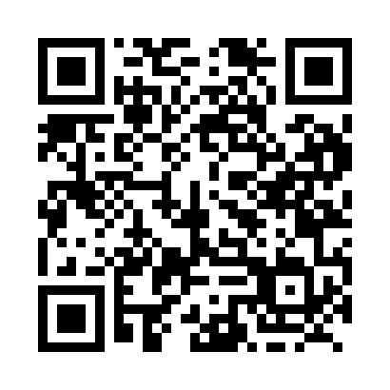
Prayer times for Snug Cove, British Columbia, Canada
Mon 1 Jul 2024 - Wed 31 Jul 2024
High Latitude Method: Angle Based Rule
Prayer Calculation Method: Islamic Society of North America
Asar Calculation Method: Hanafi

Date | Day | Fajr | Sunrise | Dhuhr | Asr | Maghrib | Isha
1 | Mon | 3:15 | 5:12 | 1:17 | 6:49 | 9:23 | 11:20
2 | Tue | 3:15 | 5:13 | 1:18 | 6:49 | 9:22 | 11:20
3 | Wed | 3:15 | 5:13 | 1:18 | 6:48 | 9:22 | 11:20
4 | Thu | 3:16 | 5:14 | 1:18 | 6:48 | 9:21 | 11:20
5 | Fri | 3:16 | 5:15 | 1:18 | 6:48 | 9:21 | 11:19
6 | Sat | 3:17 | 5:16 | 1:18 | 6:48 | 9:20 | 11:19
7 | Sun | 3:17 | 5:17 | 1:18 | 6:48 | 9:20 | 11:19
8 | Mon | 3:18 | 5:17 | 1:19 | 6:47 | 9:19 | 11:19
9 | Tue | 3:18 | 5:18 | 1:19 | 6:47 | 9:19 | 11:19
10 | Wed | 3:19 | 5:19 | 1:19 | 6:47 | 9:18 | 11:18
11 | Thu | 3:20 | 5:20 | 1:19 | 6:47 | 9:17 | 11:18
12 | Fri | 3:20 | 5:21 | 1:19 | 6:46 | 9:16 | 11:18
13 | Sat | 3:21 | 5:22 | 1:19 | 6:46 | 9:16 | 11:17
14 | Sun | 3:21 | 5:23 | 1:19 | 6:45 | 9:15 | 11:17
15 | Mon | 3:22 | 5:25 | 1:19 | 6:45 | 9:14 | 11:16
16 | Tue | 3:22 | 5:26 | 1:20 | 6:44 | 9:13 | 11:16
17 | Wed | 3:23 | 5:27 | 1:20 | 6:44 | 9:12 | 11:16
18 | Thu | 3:24 | 5:28 | 1:20 | 6:43 | 9:11 | 11:15
19 | Fri | 3:24 | 5:29 | 1:20 | 6:43 | 9:10 | 11:15
20 | Sat | 3:25 | 5:30 | 1:20 | 6:42 | 9:09 | 11:14
21 | Sun | 3:26 | 5:32 | 1:20 | 6:42 | 9:07 | 11:14
22 | Mon | 3:27 | 5:33 | 1:20 | 6:41 | 9:06 | 11:12
23 | Tue | 3:29 | 5:34 | 1:20 | 6:40 | 9:05 | 11:09
24 | Wed | 3:32 | 5:35 | 1:20 | 6:39 | 9:04 | 11:07
25 | Thu | 3:34 | 5:37 | 1:20 | 6:39 | 9:03 | 11:05
26 | Fri | 3:36 | 5:38 | 1:20 | 6:38 | 9:01 | 11:02
27 | Sat | 3:39 | 5:39 | 1:20 | 6:37 | 9:00 | 11:00
28 | Sun | 3:41 | 5:41 | 1:20 | 6:36 | 8:58 | 10:57
29 | Mon | 3:43 | 5:42 | 1:20 | 6:35 | 8:57 | 10:55
30 | Tue | 3:46 | 5:43 | 1:20 | 6:35 | 8:56 | 10:53
31 | Wed | 3:48 | 5:45 | 1:20 | 6:34 | 8:54 | 10:50
Prayer times provided by https://www.salahtimes.com

