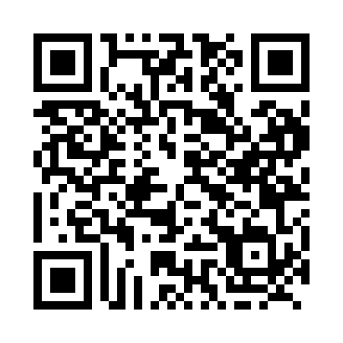
Prayer times for Cole Bay, Saskatchewan, Canada
Mon 1 Jul 2024 - Wed 31 Jul 2024
High Latitude Method: Angle Based Rule
Prayer Calculation Method: Islamic Society of North America
Asar Calculation Method: Hanafi

Date | Day | Fajr | Sunrise | Dhuhr | Asr | Maghrib | Isha
1 | Mon | 2:58 | 4:39 | 1:17 | 7:02 | 9:55 | 11:36
2 | Tue | 2:59 | 4:40 | 1:18 | 7:02 | 9:55 | 11:36
3 | Wed | 2:59 | 4:41 | 1:18 | 7:02 | 9:54 | 11:36
4 | Thu | 3:00 | 4:42 | 1:18 | 7:02 | 9:54 | 11:36
5 | Fri | 3:00 | 4:43 | 1:18 | 7:01 | 9:53 | 11:35
6 | Sat | 3:01 | 4:44 | 1:18 | 7:01 | 9:52 | 11:35
7 | Sun | 3:02 | 4:45 | 1:18 | 7:01 | 9:51 | 11:35
8 | Mon | 3:02 | 4:46 | 1:19 | 7:00 | 9:51 | 11:34
9 | Tue | 3:03 | 4:47 | 1:19 | 7:00 | 9:50 | 11:34
10 | Wed | 3:03 | 4:48 | 1:19 | 6:59 | 9:49 | 11:34
11 | Thu | 3:04 | 4:50 | 1:19 | 6:59 | 9:48 | 11:33
12 | Fri | 3:05 | 4:51 | 1:19 | 6:59 | 9:47 | 11:33
13 | Sat | 3:06 | 4:52 | 1:19 | 6:58 | 9:45 | 11:32
14 | Sun | 3:06 | 4:54 | 1:19 | 6:57 | 9:44 | 11:32
15 | Mon | 3:07 | 4:55 | 1:19 | 6:57 | 9:43 | 11:31
16 | Tue | 3:08 | 4:57 | 1:19 | 6:56 | 9:42 | 11:30
17 | Wed | 3:09 | 4:58 | 1:20 | 6:55 | 9:40 | 11:30
18 | Thu | 3:09 | 5:00 | 1:20 | 6:55 | 9:39 | 11:29
19 | Fri | 3:10 | 5:01 | 1:20 | 6:54 | 9:38 | 11:28
20 | Sat | 3:11 | 5:03 | 1:20 | 6:53 | 9:36 | 11:28
21 | Sun | 3:12 | 5:04 | 1:20 | 6:52 | 9:35 | 11:27
22 | Mon | 3:13 | 5:06 | 1:20 | 6:52 | 9:33 | 11:26
23 | Tue | 3:13 | 5:08 | 1:20 | 6:51 | 9:31 | 11:25
24 | Wed | 3:14 | 5:09 | 1:20 | 6:50 | 9:30 | 11:25
25 | Thu | 3:15 | 5:11 | 1:20 | 6:49 | 9:28 | 11:24
26 | Fri | 3:16 | 5:13 | 1:20 | 6:48 | 9:26 | 11:23
27 | Sat | 3:17 | 5:14 | 1:20 | 6:47 | 9:25 | 11:22
28 | Sun | 3:18 | 5:16 | 1:20 | 6:46 | 9:23 | 11:21
29 | Mon | 3:19 | 5:18 | 1:20 | 6:45 | 9:21 | 11:20
30 | Tue | 3:19 | 5:20 | 1:20 | 6:44 | 9:19 | 11:19
31 | Wed | 3:20 | 5:21 | 1:20 | 6:43 | 9:17 | 11:18
Prayer times provided by https://www.salahtimes.com

