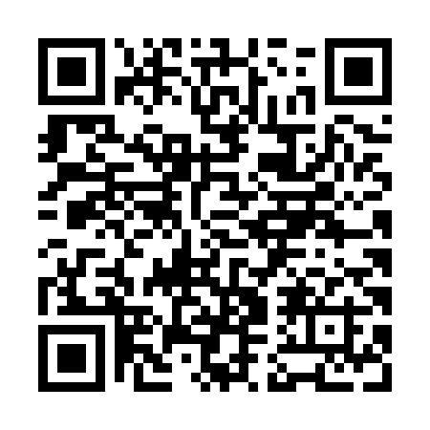
Prayer times for Char Pakshi, Bangladesh
Wed 1 May 2024 - Fri 31 May 2024
High Latitude Method: None
Prayer Calculation Method: University of Islamic Sciences
Asar Calculation Method: Shafi

Date | Day | Fajr | Sunrise | Dhuhr | Asr | Maghrib | Isha
1 | Wed | 4:04 | 5:24 | 11:54 | 3:19 | 6:25 | 7:45
2 | Thu | 4:03 | 5:23 | 11:54 | 3:18 | 6:25 | 7:46
3 | Fri | 4:02 | 5:23 | 11:54 | 3:18 | 6:26 | 7:46
4 | Sat | 4:02 | 5:22 | 11:54 | 3:18 | 6:26 | 7:47
5 | Sun | 4:01 | 5:22 | 11:54 | 3:17 | 6:27 | 7:48
6 | Mon | 4:00 | 5:21 | 11:54 | 3:17 | 6:27 | 7:48
7 | Tue | 3:59 | 5:20 | 11:54 | 3:17 | 6:28 | 7:49
8 | Wed | 3:58 | 5:20 | 11:54 | 3:17 | 6:28 | 7:50
9 | Thu | 3:58 | 5:19 | 11:54 | 3:16 | 6:28 | 7:50
10 | Fri | 3:57 | 5:19 | 11:54 | 3:16 | 6:29 | 7:51
11 | Sat | 3:56 | 5:18 | 11:54 | 3:16 | 6:29 | 7:51
12 | Sun | 3:55 | 5:18 | 11:54 | 3:16 | 6:30 | 7:52
13 | Mon | 3:55 | 5:17 | 11:54 | 3:15 | 6:30 | 7:53
14 | Tue | 3:54 | 5:17 | 11:54 | 3:15 | 6:31 | 7:53
15 | Wed | 3:53 | 5:16 | 11:54 | 3:15 | 6:31 | 7:54
16 | Thu | 3:53 | 5:16 | 11:54 | 3:15 | 6:32 | 7:55
17 | Fri | 3:52 | 5:15 | 11:54 | 3:15 | 6:32 | 7:55
18 | Sat | 3:52 | 5:15 | 11:54 | 3:14 | 6:33 | 7:56
19 | Sun | 3:51 | 5:15 | 11:54 | 3:14 | 6:33 | 7:57
20 | Mon | 3:51 | 5:14 | 11:54 | 3:14 | 6:34 | 7:57
21 | Tue | 3:50 | 5:14 | 11:54 | 3:14 | 6:34 | 7:58
22 | Wed | 3:50 | 5:14 | 11:54 | 3:14 | 6:35 | 7:59
23 | Thu | 3:49 | 5:13 | 11:54 | 3:14 | 6:35 | 7:59
24 | Fri | 3:49 | 5:13 | 11:54 | 3:13 | 6:35 | 8:00
25 | Sat | 3:48 | 5:13 | 11:54 | 3:13 | 6:36 | 8:01
26 | Sun | 3:48 | 5:12 | 11:54 | 3:13 | 6:36 | 8:01
27 | Mon | 3:47 | 5:12 | 11:54 | 3:13 | 6:37 | 8:02
28 | Tue | 3:47 | 5:12 | 11:55 | 3:13 | 6:37 | 8:02
29 | Wed | 3:47 | 5:12 | 11:55 | 3:13 | 6:38 | 8:03
30 | Thu | 3:46 | 5:12 | 11:55 | 3:13 | 6:38 | 8:04
31 | Fri | 3:46 | 5:12 | 11:55 | 3:13 | 6:39 | 8:04
Prayer times provided by https://www.salahtimes.com

