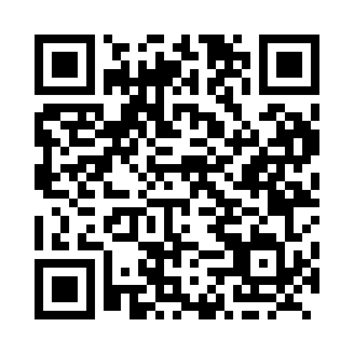
Prayer times for Alexis, Alberta, Canada
Wed 1 May 2024 - Fri 31 May 2024
High Latitude Method: Angle Based Rule
Prayer Calculation Method: Islamic Society of North America
Asar Calculation Method: Hanafi

Date | Day | Fajr | Sunrise | Dhuhr | Asr | Maghrib | Isha
1 | Wed | 3:52 | 6:01 | 1:35 | 6:45 | 9:10 | 11:20
2 | Thu | 3:48 | 5:59 | 1:35 | 6:46 | 9:12 | 11:23
3 | Fri | 3:46 | 5:57 | 1:35 | 6:47 | 9:14 | 11:24
4 | Sat | 3:45 | 5:55 | 1:35 | 6:48 | 9:15 | 11:25
5 | Sun | 3:44 | 5:53 | 1:35 | 6:50 | 9:17 | 11:26
6 | Mon | 3:43 | 5:51 | 1:35 | 6:51 | 9:19 | 11:27
7 | Tue | 3:42 | 5:49 | 1:34 | 6:52 | 9:21 | 11:28
8 | Wed | 3:41 | 5:47 | 1:34 | 6:53 | 9:23 | 11:29
9 | Thu | 3:40 | 5:45 | 1:34 | 6:54 | 9:24 | 11:30
10 | Fri | 3:39 | 5:44 | 1:34 | 6:55 | 9:26 | 11:30
11 | Sat | 3:38 | 5:42 | 1:34 | 6:56 | 9:28 | 11:31
12 | Sun | 3:37 | 5:40 | 1:34 | 6:57 | 9:29 | 11:32
13 | Mon | 3:37 | 5:38 | 1:34 | 6:58 | 9:31 | 11:33
14 | Tue | 3:36 | 5:37 | 1:34 | 6:59 | 9:33 | 11:34
15 | Wed | 3:35 | 5:35 | 1:34 | 7:00 | 9:34 | 11:35
16 | Thu | 3:34 | 5:33 | 1:34 | 7:01 | 9:36 | 11:35
17 | Fri | 3:33 | 5:32 | 1:34 | 7:02 | 9:38 | 11:36
18 | Sat | 3:33 | 5:30 | 1:34 | 7:03 | 9:39 | 11:37
19 | Sun | 3:32 | 5:29 | 1:34 | 7:03 | 9:41 | 11:38
20 | Mon | 3:31 | 5:27 | 1:35 | 7:04 | 9:42 | 11:39
21 | Tue | 3:30 | 5:26 | 1:35 | 7:05 | 9:44 | 11:39
22 | Wed | 3:30 | 5:25 | 1:35 | 7:06 | 9:45 | 11:40
23 | Thu | 3:29 | 5:23 | 1:35 | 7:07 | 9:47 | 11:41
24 | Fri | 3:29 | 5:22 | 1:35 | 7:08 | 9:48 | 11:42
25 | Sat | 3:28 | 5:21 | 1:35 | 7:09 | 9:50 | 11:43
26 | Sun | 3:28 | 5:20 | 1:35 | 7:09 | 9:51 | 11:43
27 | Mon | 3:27 | 5:18 | 1:35 | 7:10 | 9:53 | 11:44
28 | Tue | 3:27 | 5:17 | 1:35 | 7:11 | 9:54 | 11:45
29 | Wed | 3:26 | 5:16 | 1:35 | 7:12 | 9:55 | 11:45
30 | Thu | 3:26 | 5:15 | 1:36 | 7:12 | 9:56 | 11:46
31 | Fri | 3:25 | 5:14 | 1:36 | 7:13 | 9:58 | 11:47
Prayer times provided by https://www.salahtimes.com

