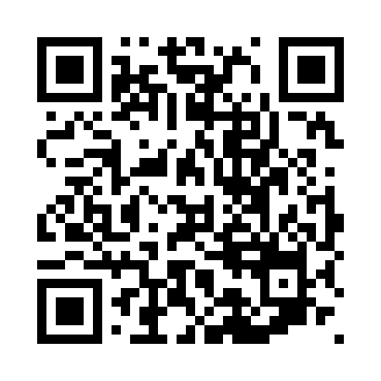
Prayer times for Bikogo, Cameroon
Wed 1 May 2024 - Fri 31 May 2024
High Latitude Method: None
Prayer Calculation Method: Muslim World League
Asar Calculation Method: Shafi

Date | Day | Fajr | Sunrise | Dhuhr | Asr | Maghrib | Isha
1 | Wed | 4:52 | 6:04 | 12:12 | 3:31 | 6:20 | 7:27
2 | Thu | 4:52 | 6:04 | 12:12 | 3:31 | 6:20 | 7:27
3 | Fri | 4:51 | 6:03 | 12:12 | 3:31 | 6:20 | 7:28
4 | Sat | 4:51 | 6:03 | 12:11 | 3:31 | 6:20 | 7:28
5 | Sun | 4:51 | 6:03 | 12:11 | 3:32 | 6:20 | 7:28
6 | Mon | 4:51 | 6:03 | 12:11 | 3:32 | 6:20 | 7:28
7 | Tue | 4:50 | 6:03 | 12:11 | 3:32 | 6:20 | 7:28
8 | Wed | 4:50 | 6:03 | 12:11 | 3:32 | 6:20 | 7:28
9 | Thu | 4:50 | 6:02 | 12:11 | 3:33 | 6:20 | 7:28
10 | Fri | 4:50 | 6:02 | 12:11 | 3:33 | 6:20 | 7:29
11 | Sat | 4:49 | 6:02 | 12:11 | 3:33 | 6:20 | 7:29
12 | Sun | 4:49 | 6:02 | 12:11 | 3:33 | 6:20 | 7:29
13 | Mon | 4:49 | 6:02 | 12:11 | 3:34 | 6:20 | 7:29
14 | Tue | 4:49 | 6:02 | 12:11 | 3:34 | 6:20 | 7:29
15 | Wed | 4:49 | 6:02 | 12:11 | 3:34 | 6:20 | 7:29
16 | Thu | 4:48 | 6:02 | 12:11 | 3:34 | 6:21 | 7:30
17 | Fri | 4:48 | 6:02 | 12:11 | 3:35 | 6:21 | 7:30
18 | Sat | 4:48 | 6:02 | 12:11 | 3:35 | 6:21 | 7:30
19 | Sun | 4:48 | 6:02 | 12:11 | 3:35 | 6:21 | 7:30
20 | Mon | 4:48 | 6:02 | 12:11 | 3:35 | 6:21 | 7:31
21 | Tue | 4:48 | 6:02 | 12:11 | 3:36 | 6:21 | 7:31
22 | Wed | 4:48 | 6:02 | 12:11 | 3:36 | 6:21 | 7:31
23 | Thu | 4:47 | 6:02 | 12:12 | 3:36 | 6:21 | 7:31
24 | Fri | 4:47 | 6:02 | 12:12 | 3:37 | 6:22 | 7:32
25 | Sat | 4:47 | 6:02 | 12:12 | 3:37 | 6:22 | 7:32
26 | Sun | 4:47 | 6:02 | 12:12 | 3:37 | 6:22 | 7:32
27 | Mon | 4:47 | 6:02 | 12:12 | 3:37 | 6:22 | 7:32
28 | Tue | 4:47 | 6:02 | 12:12 | 3:38 | 6:22 | 7:33
29 | Wed | 4:47 | 6:02 | 12:12 | 3:38 | 6:23 | 7:33
30 | Thu | 4:47 | 6:02 | 12:12 | 3:38 | 6:23 | 7:33
31 | Fri | 4:47 | 6:02 | 12:13 | 3:38 | 6:23 | 7:33
Prayer times provided by https://www.salahtimes.com

