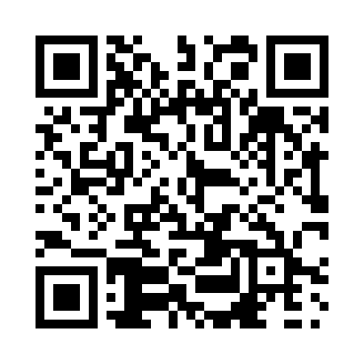
Prayer times for Starlight, Alberta, Canada
Mon 1 Jul 2024 - Wed 31 Jul 2024
High Latitude Method: Angle Based Rule
Prayer Calculation Method: Islamic Society of North America
Asar Calculation Method: Hanafi

Date | Day | Fajr | Sunrise | Dhuhr | Asr | Maghrib | Isha
1 | Mon | 3:34 | 5:27 | 1:41 | 7:15 | 9:54 | 11:47
2 | Tue | 3:34 | 5:28 | 1:41 | 7:15 | 9:54 | 11:47
3 | Wed | 3:35 | 5:29 | 1:41 | 7:15 | 9:53 | 11:47
4 | Thu | 3:35 | 5:30 | 1:41 | 7:15 | 9:53 | 11:47
5 | Fri | 3:36 | 5:30 | 1:41 | 7:15 | 9:52 | 11:47
6 | Sat | 3:36 | 5:31 | 1:42 | 7:15 | 9:52 | 11:47
7 | Sun | 3:37 | 5:32 | 1:42 | 7:14 | 9:51 | 11:46
8 | Mon | 3:37 | 5:33 | 1:42 | 7:14 | 9:50 | 11:46
9 | Tue | 3:38 | 5:34 | 1:42 | 7:14 | 9:50 | 11:46
10 | Wed | 3:39 | 5:35 | 1:42 | 7:14 | 9:49 | 11:45
11 | Thu | 3:39 | 5:36 | 1:42 | 7:13 | 9:48 | 11:45
12 | Fri | 3:40 | 5:37 | 1:42 | 7:13 | 9:47 | 11:45
13 | Sat | 3:40 | 5:38 | 1:43 | 7:12 | 9:46 | 11:44
14 | Sun | 3:41 | 5:40 | 1:43 | 7:12 | 9:45 | 11:44
15 | Mon | 3:42 | 5:41 | 1:43 | 7:11 | 9:44 | 11:43
16 | Tue | 3:42 | 5:42 | 1:43 | 7:11 | 9:43 | 11:43
17 | Wed | 3:43 | 5:43 | 1:43 | 7:10 | 9:42 | 11:42
18 | Thu | 3:44 | 5:44 | 1:43 | 7:10 | 9:41 | 11:42
19 | Fri | 3:44 | 5:46 | 1:43 | 7:09 | 9:40 | 11:41
20 | Sat | 3:45 | 5:47 | 1:43 | 7:08 | 9:39 | 11:41
21 | Sun | 3:46 | 5:48 | 1:43 | 7:08 | 9:38 | 11:40
22 | Mon | 3:46 | 5:50 | 1:43 | 7:07 | 9:36 | 11:40
23 | Tue | 3:47 | 5:51 | 1:43 | 7:06 | 9:35 | 11:39
24 | Wed | 3:48 | 5:52 | 1:43 | 7:06 | 9:34 | 11:38
25 | Thu | 3:48 | 5:54 | 1:43 | 7:05 | 9:32 | 11:38
26 | Fri | 3:49 | 5:55 | 1:43 | 7:04 | 9:31 | 11:37
27 | Sat | 3:50 | 5:56 | 1:43 | 7:03 | 9:29 | 11:36
28 | Sun | 3:50 | 5:58 | 1:43 | 7:02 | 9:28 | 11:35
29 | Mon | 3:51 | 5:59 | 1:43 | 7:01 | 9:26 | 11:33
30 | Tue | 3:54 | 6:01 | 1:43 | 7:00 | 9:25 | 11:31
31 | Wed | 3:57 | 6:02 | 1:43 | 6:59 | 9:23 | 11:28
Prayer times provided by https://www.salahtimes.com

