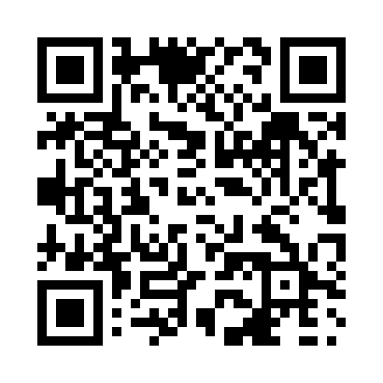
Prayer times for Glen Leslie, Alberta, Canada
Wed 1 May 2024 - Fri 31 May 2024
High Latitude Method: Angle Based Rule
Prayer Calculation Method: Islamic Society of North America
Asar Calculation Method: Hanafi

Date | Day | Fajr | Sunrise | Dhuhr | Asr | Maghrib | Isha
1 | Wed | 4:01 | 6:11 | 1:51 | 7:03 | 9:32 | 11:42
2 | Thu | 4:00 | 6:09 | 1:51 | 7:04 | 9:33 | 11:42
3 | Fri | 3:59 | 6:07 | 1:51 | 7:05 | 9:35 | 11:43
4 | Sat | 3:58 | 6:05 | 1:51 | 7:06 | 9:37 | 11:44
5 | Sun | 3:57 | 6:03 | 1:51 | 7:08 | 9:39 | 11:45
6 | Mon | 3:56 | 6:01 | 1:51 | 7:09 | 9:41 | 11:46
7 | Tue | 3:55 | 5:59 | 1:50 | 7:10 | 9:43 | 11:47
8 | Wed | 3:54 | 5:57 | 1:50 | 7:11 | 9:45 | 11:48
9 | Thu | 3:53 | 5:55 | 1:50 | 7:12 | 9:47 | 11:49
10 | Fri | 3:52 | 5:53 | 1:50 | 7:13 | 9:49 | 11:50
11 | Sat | 3:51 | 5:51 | 1:50 | 7:14 | 9:50 | 11:51
12 | Sun | 3:50 | 5:49 | 1:50 | 7:15 | 9:52 | 11:52
13 | Mon | 3:49 | 5:47 | 1:50 | 7:16 | 9:54 | 11:52
14 | Tue | 3:48 | 5:46 | 1:50 | 7:17 | 9:56 | 11:53
15 | Wed | 3:47 | 5:44 | 1:50 | 7:18 | 9:58 | 11:54
16 | Thu | 3:46 | 5:42 | 1:50 | 7:19 | 9:59 | 11:55
17 | Fri | 3:46 | 5:40 | 1:50 | 7:20 | 10:01 | 11:56
18 | Sat | 3:45 | 5:39 | 1:50 | 7:21 | 10:03 | 11:57
19 | Sun | 3:44 | 5:37 | 1:50 | 7:22 | 10:05 | 11:58
20 | Mon | 3:43 | 5:36 | 1:51 | 7:23 | 10:06 | 11:59
21 | Tue | 3:43 | 5:34 | 1:51 | 7:24 | 10:08 | 11:59
22 | Wed | 3:42 | 5:33 | 1:51 | 7:25 | 10:10 | 12:00
23 | Thu | 3:41 | 5:31 | 1:51 | 7:26 | 10:11 | 12:01
24 | Fri | 3:41 | 5:30 | 1:51 | 7:27 | 10:13 | 12:02
25 | Sat | 3:40 | 5:28 | 1:51 | 7:28 | 10:14 | 12:03
26 | Sun | 3:39 | 5:27 | 1:51 | 7:29 | 10:16 | 12:04
27 | Mon | 3:39 | 5:26 | 1:51 | 7:29 | 10:17 | 12:04
28 | Tue | 3:38 | 5:25 | 1:51 | 7:30 | 10:19 | 12:05
29 | Wed | 3:38 | 5:24 | 1:51 | 7:31 | 10:20 | 12:06
30 | Thu | 3:37 | 5:22 | 1:52 | 7:32 | 10:21 | 12:07
31 | Fri | 3:37 | 5:21 | 1:52 | 7:33 | 10:23 | 12:07
Prayer times provided by https://www.salahtimes.com

