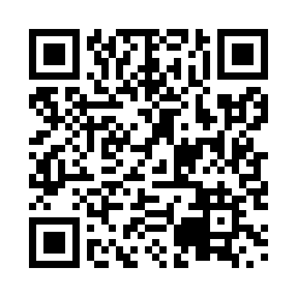
Prayer times for Back Shore, Newfoundland and Labrador, Canada
Wed 1 May 2024 - Fri 31 May 2024
High Latitude Method: Angle Based Rule
Prayer Calculation Method: Islamic Society of North America
Asar Calculation Method: Hanafi

Date | Day | Fajr | Sunrise | Dhuhr | Asr | Maghrib | Isha
1 | Wed | 4:10 | 5:49 | 1:01 | 6:03 | 8:15 | 9:54
2 | Thu | 4:08 | 5:47 | 1:01 | 6:04 | 8:16 | 9:56
3 | Fri | 4:06 | 5:46 | 1:01 | 6:05 | 8:17 | 9:58
4 | Sat | 4:04 | 5:44 | 1:01 | 6:06 | 8:19 | 9:59
5 | Sun | 4:02 | 5:43 | 1:01 | 6:07 | 8:20 | 10:01
6 | Mon | 4:00 | 5:41 | 1:01 | 6:07 | 8:21 | 10:03
7 | Tue | 3:58 | 5:40 | 1:01 | 6:08 | 8:22 | 10:05
8 | Wed | 3:56 | 5:39 | 1:01 | 6:09 | 8:24 | 10:07
9 | Thu | 3:53 | 5:37 | 1:01 | 6:10 | 8:25 | 10:09
10 | Fri | 3:51 | 5:36 | 1:01 | 6:10 | 8:26 | 10:11
11 | Sat | 3:49 | 5:35 | 1:01 | 6:11 | 8:28 | 10:13
12 | Sun | 3:47 | 5:33 | 1:01 | 6:12 | 8:29 | 10:15
13 | Mon | 3:46 | 5:32 | 1:01 | 6:13 | 8:30 | 10:17
14 | Tue | 3:44 | 5:31 | 1:01 | 6:13 | 8:31 | 10:19
15 | Wed | 3:42 | 5:30 | 1:01 | 6:14 | 8:32 | 10:21
16 | Thu | 3:40 | 5:28 | 1:01 | 6:15 | 8:34 | 10:23
17 | Fri | 3:38 | 5:27 | 1:01 | 6:16 | 8:35 | 10:25
18 | Sat | 3:36 | 5:26 | 1:01 | 6:16 | 8:36 | 10:26
19 | Sun | 3:34 | 5:25 | 1:01 | 6:17 | 8:37 | 10:28
20 | Mon | 3:33 | 5:24 | 1:01 | 6:18 | 8:38 | 10:30
21 | Tue | 3:31 | 5:23 | 1:01 | 6:18 | 8:39 | 10:32
22 | Wed | 3:29 | 5:22 | 1:01 | 6:19 | 8:41 | 10:34
23 | Thu | 3:28 | 5:21 | 1:01 | 6:20 | 8:42 | 10:36
24 | Fri | 3:26 | 5:20 | 1:01 | 6:20 | 8:43 | 10:37
25 | Sat | 3:24 | 5:19 | 1:01 | 6:21 | 8:44 | 10:39
26 | Sun | 3:23 | 5:19 | 1:01 | 6:22 | 8:45 | 10:41
27 | Mon | 3:21 | 5:18 | 1:02 | 6:22 | 8:46 | 10:43
28 | Tue | 3:20 | 5:17 | 1:02 | 6:23 | 8:47 | 10:44
29 | Wed | 3:19 | 5:16 | 1:02 | 6:23 | 8:48 | 10:46
30 | Thu | 3:17 | 5:16 | 1:02 | 6:24 | 8:49 | 10:47
31 | Fri | 3:16 | 5:15 | 1:02 | 6:25 | 8:50 | 10:49
Prayer times provided by https://www.salahtimes.com

