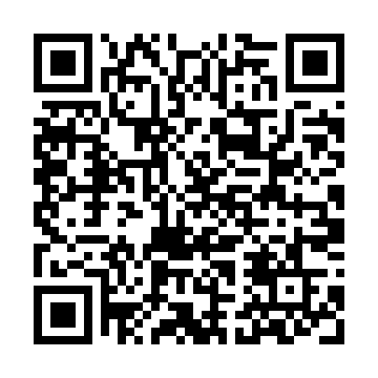
Prayer times for Lons-le-Saunier, France
Wed 1 May 2024 - Fri 31 May 2024
High Latitude Method: Angle Based Rule
Prayer Calculation Method: Islamic Organisations Union of France
Asar Calculation Method: Shafi

Date | Day | Fajr | Sunrise | Dhuhr | Asr | Maghrib | Isha
1 | Wed | 5:07 | 6:23 | 1:35 | 5:33 | 8:48 | 10:04
2 | Thu | 5:05 | 6:21 | 1:35 | 5:33 | 8:49 | 10:06
3 | Fri | 5:03 | 6:19 | 1:35 | 5:34 | 8:51 | 10:07
4 | Sat | 5:01 | 6:18 | 1:35 | 5:34 | 8:52 | 10:09
5 | Sun | 4:59 | 6:16 | 1:34 | 5:35 | 8:53 | 10:11
6 | Mon | 4:57 | 6:15 | 1:34 | 5:35 | 8:55 | 10:13
7 | Tue | 4:55 | 6:14 | 1:34 | 5:36 | 8:56 | 10:14
8 | Wed | 4:53 | 6:12 | 1:34 | 5:36 | 8:57 | 10:16
9 | Thu | 4:52 | 6:11 | 1:34 | 5:37 | 8:58 | 10:18
10 | Fri | 4:50 | 6:09 | 1:34 | 5:37 | 9:00 | 10:20
11 | Sat | 4:48 | 6:08 | 1:34 | 5:38 | 9:01 | 10:21
12 | Sun | 4:46 | 6:07 | 1:34 | 5:38 | 9:02 | 10:23
13 | Mon | 4:45 | 6:06 | 1:34 | 5:39 | 9:03 | 10:25
14 | Tue | 4:43 | 6:04 | 1:34 | 5:39 | 9:05 | 10:26
15 | Wed | 4:41 | 6:03 | 1:34 | 5:39 | 9:06 | 10:28
16 | Thu | 4:40 | 6:02 | 1:34 | 5:40 | 9:07 | 10:30
17 | Fri | 4:38 | 6:01 | 1:34 | 5:40 | 9:08 | 10:31
18 | Sat | 4:36 | 6:00 | 1:34 | 5:41 | 9:09 | 10:33
19 | Sun | 4:35 | 5:59 | 1:34 | 5:41 | 9:11 | 10:35
20 | Mon | 4:33 | 5:58 | 1:34 | 5:42 | 9:12 | 10:36
21 | Tue | 4:32 | 5:57 | 1:34 | 5:42 | 9:13 | 10:38
22 | Wed | 4:31 | 5:56 | 1:35 | 5:42 | 9:14 | 10:39
23 | Thu | 4:29 | 5:55 | 1:35 | 5:43 | 9:15 | 10:41
24 | Fri | 4:28 | 5:54 | 1:35 | 5:43 | 9:16 | 10:42
25 | Sat | 4:27 | 5:53 | 1:35 | 5:44 | 9:17 | 10:44
26 | Sun | 4:25 | 5:52 | 1:35 | 5:44 | 9:18 | 10:45
27 | Mon | 4:24 | 5:51 | 1:35 | 5:44 | 9:19 | 10:47
28 | Tue | 4:23 | 5:50 | 1:35 | 5:45 | 9:20 | 10:48
29 | Wed | 4:22 | 5:50 | 1:35 | 5:45 | 9:21 | 10:50
30 | Thu | 4:21 | 5:49 | 1:35 | 5:46 | 9:22 | 10:51
31 | Fri | 4:20 | 5:48 | 1:36 | 5:46 | 9:23 | 10:52
Prayer times provided by https://www.salahtimes.com

