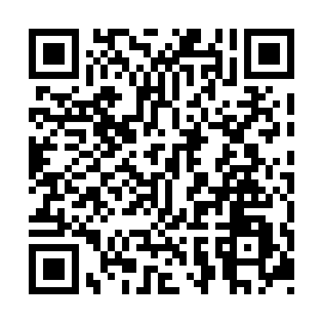
Prayer times for St. Clair Beach, Ontario, Canada
Mon 1 Jul 2024 - Wed 31 Jul 2024
High Latitude Method: Angle Based Rule
Prayer Calculation Method: Islamic Society of North America
Asar Calculation Method: Hanafi

Date | Day | Fajr | Sunrise | Dhuhr | Asr | Maghrib | Isha
1 | Mon | 4:15 | 5:59 | 1:35 | 6:52 | 9:12 | 10:56
2 | Tue | 4:16 | 5:59 | 1:36 | 6:52 | 9:12 | 10:55
3 | Wed | 4:16 | 6:00 | 1:36 | 6:52 | 9:11 | 10:55
4 | Thu | 4:17 | 6:01 | 1:36 | 6:52 | 9:11 | 10:54
5 | Fri | 4:18 | 6:01 | 1:36 | 6:52 | 9:11 | 10:54
6 | Sat | 4:19 | 6:02 | 1:36 | 6:52 | 9:11 | 10:53
7 | Sun | 4:20 | 6:03 | 1:37 | 6:52 | 9:10 | 10:53
8 | Mon | 4:21 | 6:03 | 1:37 | 6:52 | 9:10 | 10:52
9 | Tue | 4:22 | 6:04 | 1:37 | 6:51 | 9:09 | 10:51
10 | Wed | 4:23 | 6:05 | 1:37 | 6:51 | 9:09 | 10:50
11 | Thu | 4:24 | 6:05 | 1:37 | 6:51 | 9:08 | 10:49
12 | Fri | 4:25 | 6:06 | 1:37 | 6:51 | 9:08 | 10:48
13 | Sat | 4:27 | 6:07 | 1:37 | 6:51 | 9:07 | 10:47
14 | Sun | 4:28 | 6:08 | 1:37 | 6:50 | 9:07 | 10:46
15 | Mon | 4:29 | 6:09 | 1:38 | 6:50 | 9:06 | 10:45
16 | Tue | 4:30 | 6:10 | 1:38 | 6:50 | 9:05 | 10:44
17 | Wed | 4:32 | 6:10 | 1:38 | 6:49 | 9:05 | 10:43
18 | Thu | 4:33 | 6:11 | 1:38 | 6:49 | 9:04 | 10:42
19 | Fri | 4:34 | 6:12 | 1:38 | 6:49 | 9:03 | 10:41
20 | Sat | 4:35 | 6:13 | 1:38 | 6:48 | 9:02 | 10:40
21 | Sun | 4:37 | 6:14 | 1:38 | 6:48 | 9:01 | 10:38
22 | Mon | 4:38 | 6:15 | 1:38 | 6:47 | 9:01 | 10:37
23 | Tue | 4:40 | 6:16 | 1:38 | 6:47 | 9:00 | 10:36
24 | Wed | 4:41 | 6:17 | 1:38 | 6:46 | 8:59 | 10:34
25 | Thu | 4:42 | 6:18 | 1:38 | 6:46 | 8:58 | 10:33
26 | Fri | 4:44 | 6:19 | 1:38 | 6:45 | 8:57 | 10:31
27 | Sat | 4:45 | 6:20 | 1:38 | 6:45 | 8:56 | 10:30
28 | Sun | 4:47 | 6:21 | 1:38 | 6:44 | 8:55 | 10:28
29 | Mon | 4:48 | 6:22 | 1:38 | 6:43 | 8:54 | 10:27
30 | Tue | 4:49 | 6:23 | 1:38 | 6:43 | 8:52 | 10:25
31 | Wed | 4:51 | 6:24 | 1:38 | 6:42 | 8:51 | 10:24
Prayer times provided by https://www.salahtimes.com

