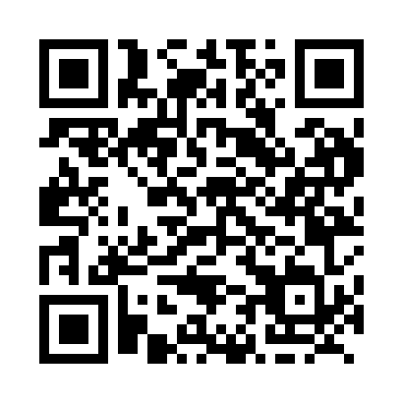
Prayer times for Gobeil, Quebec, Canada
Wed 1 May 2024 - Fri 31 May 2024
High Latitude Method: Angle Based Rule
Prayer Calculation Method: Islamic Society of North America
Asar Calculation Method: Hanafi

Date | Day | Fajr | Sunrise | Dhuhr | Asr | Maghrib | Isha
1 | Wed | 3:43 | 5:24 | 12:39 | 5:42 | 7:54 | 9:36
2 | Thu | 3:41 | 5:23 | 12:39 | 5:43 | 7:56 | 9:38
3 | Fri | 3:39 | 5:21 | 12:39 | 5:44 | 7:57 | 9:40
4 | Sat | 3:36 | 5:20 | 12:39 | 5:45 | 7:59 | 9:42
5 | Sun | 3:34 | 5:18 | 12:39 | 5:45 | 8:00 | 9:44
6 | Mon | 3:32 | 5:17 | 12:39 | 5:46 | 8:01 | 9:46
7 | Tue | 3:30 | 5:15 | 12:39 | 5:47 | 8:03 | 9:48
8 | Wed | 3:28 | 5:14 | 12:38 | 5:48 | 8:04 | 9:50
9 | Thu | 3:26 | 5:12 | 12:38 | 5:49 | 8:05 | 9:52
10 | Fri | 3:24 | 5:11 | 12:38 | 5:49 | 8:07 | 9:54
11 | Sat | 3:21 | 5:10 | 12:38 | 5:50 | 8:08 | 9:56
12 | Sun | 3:19 | 5:08 | 12:38 | 5:51 | 8:09 | 9:59
13 | Mon | 3:17 | 5:07 | 12:38 | 5:52 | 8:10 | 10:01
14 | Tue | 3:15 | 5:06 | 12:38 | 5:52 | 8:12 | 10:03
15 | Wed | 3:13 | 5:04 | 12:38 | 5:53 | 8:13 | 10:05
16 | Thu | 3:11 | 5:03 | 12:38 | 5:54 | 8:14 | 10:07
17 | Fri | 3:09 | 5:02 | 12:38 | 5:55 | 8:15 | 10:09
18 | Sat | 3:07 | 5:01 | 12:38 | 5:55 | 8:17 | 10:11
19 | Sun | 3:05 | 5:00 | 12:39 | 5:56 | 8:18 | 10:13
20 | Mon | 3:04 | 4:59 | 12:39 | 5:57 | 8:19 | 10:15
21 | Tue | 3:02 | 4:58 | 12:39 | 5:57 | 8:20 | 10:17
22 | Wed | 3:00 | 4:57 | 12:39 | 5:58 | 8:21 | 10:19
23 | Thu | 2:58 | 4:56 | 12:39 | 5:59 | 8:22 | 10:20
24 | Fri | 2:56 | 4:55 | 12:39 | 5:59 | 8:24 | 10:22
25 | Sat | 2:55 | 4:54 | 12:39 | 6:00 | 8:25 | 10:24
26 | Sun | 2:53 | 4:53 | 12:39 | 6:01 | 8:26 | 10:26
27 | Mon | 2:52 | 4:52 | 12:39 | 6:01 | 8:27 | 10:28
28 | Tue | 2:50 | 4:51 | 12:39 | 6:02 | 8:28 | 10:30
29 | Wed | 2:48 | 4:51 | 12:40 | 6:03 | 8:29 | 10:31
30 | Thu | 2:47 | 4:50 | 12:40 | 6:03 | 8:30 | 10:33
31 | Fri | 2:46 | 4:49 | 12:40 | 6:04 | 8:31 | 10:35
Prayer times provided by https://www.salahtimes.com

