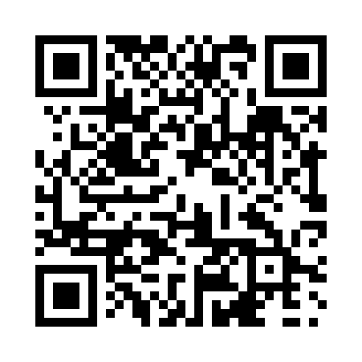
Prayer times for Anaconda, British Columbia, Canada
Mon 1 Apr 2024 - Tue 30 Apr 2024
High Latitude Method: Angle Based Rule
Prayer Calculation Method: Islamic Society of North America
Asar Calculation Method: Hanafi

Date | Day | Fajr | Sunrise | Dhuhr | Asr | Maghrib | Isha
1 | Mon | 5:00 | 6:31 | 12:58 | 5:27 | 7:27 | 8:58
2 | Tue | 4:57 | 6:29 | 12:58 | 5:28 | 7:28 | 9:00
3 | Wed | 4:55 | 6:27 | 12:58 | 5:29 | 7:30 | 9:02
4 | Thu | 4:53 | 6:24 | 12:57 | 5:30 | 7:31 | 9:04
5 | Fri | 4:50 | 6:22 | 12:57 | 5:31 | 7:33 | 9:05
6 | Sat | 4:48 | 6:20 | 12:57 | 5:32 | 7:34 | 9:07
7 | Sun | 4:45 | 6:18 | 12:57 | 5:33 | 7:36 | 9:09
8 | Mon | 4:43 | 6:16 | 12:56 | 5:34 | 7:37 | 9:11
9 | Tue | 4:40 | 6:14 | 12:56 | 5:35 | 7:39 | 9:13
10 | Wed | 4:38 | 6:12 | 12:56 | 5:36 | 7:40 | 9:15
11 | Thu | 4:35 | 6:10 | 12:56 | 5:37 | 7:42 | 9:17
12 | Fri | 4:33 | 6:08 | 12:55 | 5:38 | 7:43 | 9:19
13 | Sat | 4:30 | 6:06 | 12:55 | 5:39 | 7:45 | 9:21
14 | Sun | 4:28 | 6:04 | 12:55 | 5:41 | 7:46 | 9:23
15 | Mon | 4:25 | 6:02 | 12:55 | 5:42 | 7:48 | 9:25
16 | Tue | 4:23 | 6:00 | 12:54 | 5:42 | 7:49 | 9:27
17 | Wed | 4:20 | 5:58 | 12:54 | 5:43 | 7:51 | 9:29
18 | Thu | 4:18 | 5:56 | 12:54 | 5:44 | 7:53 | 9:31
19 | Fri | 4:15 | 5:54 | 12:54 | 5:45 | 7:54 | 9:33
20 | Sat | 4:13 | 5:52 | 12:53 | 5:46 | 7:56 | 9:35
21 | Sun | 4:10 | 5:50 | 12:53 | 5:47 | 7:57 | 9:37
22 | Mon | 4:08 | 5:49 | 12:53 | 5:48 | 7:59 | 9:39
23 | Tue | 4:05 | 5:47 | 12:53 | 5:49 | 8:00 | 9:42
24 | Wed | 4:03 | 5:45 | 12:53 | 5:50 | 8:01 | 9:44
25 | Thu | 4:01 | 5:43 | 12:53 | 5:51 | 8:03 | 9:46
26 | Fri | 3:58 | 5:41 | 12:52 | 5:52 | 8:04 | 9:48
27 | Sat | 3:56 | 5:39 | 12:52 | 5:53 | 8:06 | 9:50
28 | Sun | 3:53 | 5:38 | 12:52 | 5:54 | 8:07 | 9:52
29 | Mon | 3:51 | 5:36 | 12:52 | 5:55 | 8:09 | 9:55
30 | Tue | 3:48 | 5:34 | 12:52 | 5:56 | 8:10 | 9:57
Prayer times provided by https://www.salahtimes.com

