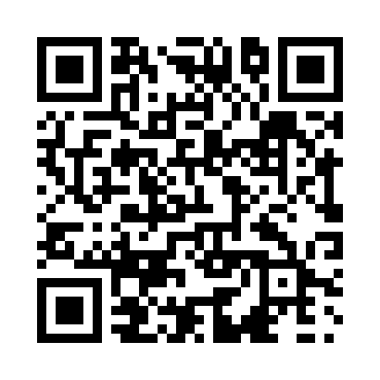
Prayer times for Barich, Alberta, Canada
Mon 1 Jul 2024 - Wed 31 Jul 2024
High Latitude Method: Angle Based Rule
Prayer Calculation Method: Islamic Society of North America
Asar Calculation Method: Hanafi

Date | Day | Fajr | Sunrise | Dhuhr | Asr | Maghrib | Isha
1 | Mon | 3:18 | 5:02 | 1:35 | 7:17 | 10:07 | 11:50
2 | Tue | 3:19 | 5:03 | 1:35 | 7:17 | 10:06 | 11:50
3 | Wed | 3:19 | 5:04 | 1:35 | 7:17 | 10:05 | 11:50
4 | Thu | 3:20 | 5:05 | 1:35 | 7:16 | 10:05 | 11:50
5 | Fri | 3:20 | 5:06 | 1:35 | 7:16 | 10:04 | 11:50
6 | Sat | 3:21 | 5:07 | 1:35 | 7:16 | 10:04 | 11:49
7 | Sun | 3:22 | 5:08 | 1:36 | 7:16 | 10:03 | 11:49
8 | Mon | 3:22 | 5:09 | 1:36 | 7:15 | 10:02 | 11:49
9 | Tue | 3:23 | 5:10 | 1:36 | 7:15 | 10:01 | 11:48
10 | Wed | 3:24 | 5:11 | 1:36 | 7:14 | 10:00 | 11:48
11 | Thu | 3:24 | 5:13 | 1:36 | 7:14 | 9:59 | 11:48
12 | Fri | 3:25 | 5:14 | 1:36 | 7:14 | 9:58 | 11:47
13 | Sat | 3:26 | 5:15 | 1:36 | 7:13 | 9:57 | 11:47
14 | Sun | 3:26 | 5:16 | 1:36 | 7:13 | 9:56 | 11:46
15 | Mon | 3:27 | 5:18 | 1:37 | 7:12 | 9:55 | 11:46
16 | Tue | 3:28 | 5:19 | 1:37 | 7:11 | 9:54 | 11:45
17 | Wed | 3:29 | 5:21 | 1:37 | 7:11 | 9:52 | 11:44
18 | Thu | 3:29 | 5:22 | 1:37 | 7:10 | 9:51 | 11:44
19 | Fri | 3:30 | 5:24 | 1:37 | 7:09 | 9:50 | 11:43
20 | Sat | 3:31 | 5:25 | 1:37 | 7:09 | 9:48 | 11:42
21 | Sun | 3:32 | 5:27 | 1:37 | 7:08 | 9:47 | 11:42
22 | Mon | 3:32 | 5:28 | 1:37 | 7:07 | 9:45 | 11:41
23 | Tue | 3:33 | 5:30 | 1:37 | 7:06 | 9:44 | 11:40
24 | Wed | 3:34 | 5:31 | 1:37 | 7:05 | 9:42 | 11:39
25 | Thu | 3:35 | 5:33 | 1:37 | 7:04 | 9:41 | 11:39
26 | Fri | 3:36 | 5:34 | 1:37 | 7:03 | 9:39 | 11:38
27 | Sat | 3:36 | 5:36 | 1:37 | 7:02 | 9:37 | 11:37
28 | Sun | 3:37 | 5:38 | 1:37 | 7:01 | 9:35 | 11:36
29 | Mon | 3:38 | 5:39 | 1:37 | 7:00 | 9:34 | 11:35
30 | Tue | 3:39 | 5:41 | 1:37 | 6:59 | 9:32 | 11:34
31 | Wed | 3:40 | 5:43 | 1:37 | 6:58 | 9:30 | 11:33
Prayer times provided by https://www.salahtimes.com

