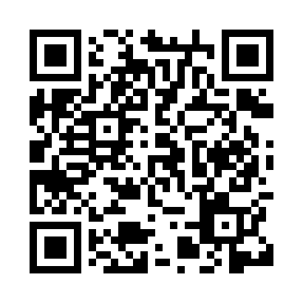
Prayer times for Ilesa, Nigeria
Wed 1 May 2024 - Fri 31 May 2024
High Latitude Method: None
Prayer Calculation Method: Egyptian General Authority of Survey
Asar Calculation Method: Shafi

Date | Day | Fajr | Sunrise | Dhuhr | Asr | Maghrib | Isha
1 | Wed | 5:07 | 6:26 | 12:38 | 3:54 | 6:50 | 8:00
2 | Thu | 5:07 | 6:26 | 12:38 | 3:55 | 6:50 | 8:01
3 | Fri | 5:07 | 6:26 | 12:38 | 3:55 | 6:50 | 8:01
4 | Sat | 5:06 | 6:25 | 12:38 | 3:56 | 6:50 | 8:01
5 | Sun | 5:06 | 6:25 | 12:38 | 3:56 | 6:50 | 8:01
6 | Mon | 5:05 | 6:25 | 12:38 | 3:56 | 6:50 | 8:01
7 | Tue | 5:05 | 6:25 | 12:38 | 3:57 | 6:51 | 8:02
8 | Wed | 5:05 | 6:25 | 12:38 | 3:57 | 6:51 | 8:02
9 | Thu | 5:04 | 6:24 | 12:38 | 3:57 | 6:51 | 8:02
10 | Fri | 5:04 | 6:24 | 12:37 | 3:58 | 6:51 | 8:02
11 | Sat | 5:04 | 6:24 | 12:37 | 3:58 | 6:51 | 8:03
12 | Sun | 5:03 | 6:24 | 12:37 | 3:58 | 6:51 | 8:03
13 | Mon | 5:03 | 6:24 | 12:37 | 3:59 | 6:51 | 8:03
14 | Tue | 5:03 | 6:23 | 12:37 | 3:59 | 6:51 | 8:03
15 | Wed | 5:03 | 6:23 | 12:37 | 3:59 | 6:52 | 8:04
16 | Thu | 5:02 | 6:23 | 12:37 | 4:00 | 6:52 | 8:04
17 | Fri | 5:02 | 6:23 | 12:37 | 4:00 | 6:52 | 8:04
18 | Sat | 5:02 | 6:23 | 12:38 | 4:00 | 6:52 | 8:05
19 | Sun | 5:02 | 6:23 | 12:38 | 4:01 | 6:52 | 8:05
20 | Mon | 5:01 | 6:23 | 12:38 | 4:01 | 6:53 | 8:05
21 | Tue | 5:01 | 6:23 | 12:38 | 4:01 | 6:53 | 8:05
22 | Wed | 5:01 | 6:23 | 12:38 | 4:02 | 6:53 | 8:06
23 | Thu | 5:01 | 6:23 | 12:38 | 4:02 | 6:53 | 8:06
24 | Fri | 5:01 | 6:23 | 12:38 | 4:02 | 6:53 | 8:06
25 | Sat | 5:01 | 6:23 | 12:38 | 4:03 | 6:54 | 8:07
26 | Sun | 5:01 | 6:23 | 12:38 | 4:03 | 6:54 | 8:07
27 | Mon | 5:00 | 6:23 | 12:38 | 4:03 | 6:54 | 8:07
28 | Tue | 5:00 | 6:23 | 12:38 | 4:04 | 6:54 | 8:08
29 | Wed | 5:00 | 6:23 | 12:39 | 4:04 | 6:54 | 8:08
30 | Thu | 5:00 | 6:23 | 12:39 | 4:04 | 6:55 | 8:08
31 | Fri | 5:00 | 6:23 | 12:39 | 4:05 | 6:55 | 8:09
Prayer times provided by https://www.salahtimes.com

