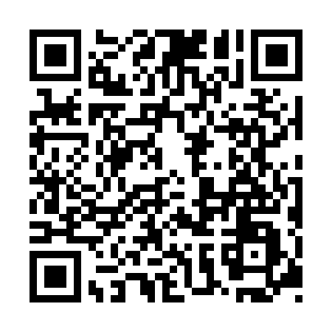
Prayer times for Unterbaimbach, Germany
Wed 1 May 2024 - Fri 31 May 2024
High Latitude Method: Angle Based Rule
Prayer Calculation Method: Muslim World League
Asar Calculation Method: Shafi

Date | Day | Fajr | Sunrise | Dhuhr | Asr | Maghrib | Isha
1 | Wed | 3:37 | 5:54 | 1:13 | 5:14 | 8:33 | 10:40
2 | Thu | 3:34 | 5:52 | 1:13 | 5:15 | 8:35 | 10:43
3 | Fri | 3:31 | 5:50 | 1:13 | 5:15 | 8:36 | 10:45
4 | Sat | 3:28 | 5:48 | 1:13 | 5:16 | 8:38 | 10:48
5 | Sun | 3:25 | 5:47 | 1:13 | 5:16 | 8:39 | 10:51
6 | Mon | 3:22 | 5:45 | 1:13 | 5:17 | 8:41 | 10:53
7 | Tue | 3:19 | 5:44 | 1:13 | 5:17 | 8:42 | 10:56
8 | Wed | 3:16 | 5:42 | 1:12 | 5:18 | 8:44 | 10:59
9 | Thu | 3:13 | 5:41 | 1:12 | 5:18 | 8:45 | 11:01
10 | Fri | 3:10 | 5:39 | 1:12 | 5:19 | 8:47 | 11:04
11 | Sat | 3:07 | 5:38 | 1:12 | 5:20 | 8:48 | 11:07
12 | Sun | 3:04 | 5:36 | 1:12 | 5:20 | 8:49 | 11:10
13 | Mon | 3:01 | 5:35 | 1:12 | 5:21 | 8:51 | 11:13
14 | Tue | 2:58 | 5:33 | 1:12 | 5:21 | 8:52 | 11:15
15 | Wed | 2:56 | 5:32 | 1:12 | 5:22 | 8:54 | 11:18
16 | Thu | 2:56 | 5:31 | 1:12 | 5:22 | 8:55 | 11:21
17 | Fri | 2:55 | 5:29 | 1:12 | 5:23 | 8:56 | 11:22
18 | Sat | 2:55 | 5:28 | 1:12 | 5:23 | 8:58 | 11:22
19 | Sun | 2:54 | 5:27 | 1:13 | 5:24 | 8:59 | 11:23
20 | Mon | 2:54 | 5:26 | 1:13 | 5:24 | 9:00 | 11:23
21 | Tue | 2:54 | 5:25 | 1:13 | 5:25 | 9:01 | 11:24
22 | Wed | 2:53 | 5:23 | 1:13 | 5:25 | 9:03 | 11:25
23 | Thu | 2:53 | 5:22 | 1:13 | 5:26 | 9:04 | 11:25
24 | Fri | 2:52 | 5:21 | 1:13 | 5:26 | 9:05 | 11:26
25 | Sat | 2:52 | 5:20 | 1:13 | 5:27 | 9:06 | 11:26
26 | Sun | 2:52 | 5:19 | 1:13 | 5:27 | 9:07 | 11:27
27 | Mon | 2:51 | 5:18 | 1:13 | 5:28 | 9:09 | 11:27
28 | Tue | 2:51 | 5:18 | 1:13 | 5:28 | 9:10 | 11:28
29 | Wed | 2:51 | 5:17 | 1:14 | 5:28 | 9:11 | 11:28
30 | Thu | 2:51 | 5:16 | 1:14 | 5:29 | 9:12 | 11:29
31 | Fri | 2:51 | 5:15 | 1:14 | 5:29 | 9:13 | 11:29
Prayer times provided by https://www.salahtimes.com

