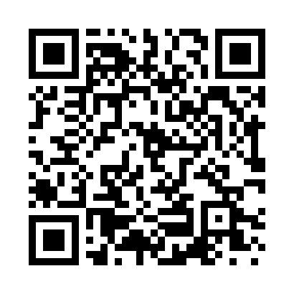
Prayer times for Sookalda, Estonia
Wed 1 May 2024 - Fri 31 May 2024
High Latitude Method: Angle Based Rule
Prayer Calculation Method: Muslim World League
Asar Calculation Method: Hanafi

Date | Day | Fajr | Sunrise | Dhuhr | Asr | Maghrib | Isha
1 | Wed | 3:01 | 5:29 | 1:22 | 6:37 | 9:16 | 11:36
2 | Thu | 3:00 | 5:26 | 1:22 | 6:39 | 9:18 | 11:37
3 | Fri | 2:59 | 5:24 | 1:22 | 6:40 | 9:21 | 11:37
4 | Sat | 2:58 | 5:21 | 1:21 | 6:41 | 9:23 | 11:38
5 | Sun | 2:57 | 5:19 | 1:21 | 6:43 | 9:25 | 11:39
6 | Mon | 2:56 | 5:16 | 1:21 | 6:44 | 9:27 | 11:40
7 | Tue | 2:55 | 5:14 | 1:21 | 6:45 | 9:30 | 11:41
8 | Wed | 2:54 | 5:12 | 1:21 | 6:47 | 9:32 | 11:42
9 | Thu | 2:53 | 5:09 | 1:21 | 6:48 | 9:34 | 11:43
10 | Fri | 2:52 | 5:07 | 1:21 | 6:49 | 9:36 | 11:44
11 | Sat | 2:51 | 5:05 | 1:21 | 6:50 | 9:38 | 11:45
12 | Sun | 2:50 | 5:03 | 1:21 | 6:52 | 9:41 | 11:46
13 | Mon | 2:49 | 5:00 | 1:21 | 6:53 | 9:43 | 11:47
14 | Tue | 2:48 | 4:58 | 1:21 | 6:54 | 9:45 | 11:48
15 | Wed | 2:47 | 4:56 | 1:21 | 6:55 | 9:47 | 11:49
16 | Thu | 2:47 | 4:54 | 1:21 | 6:56 | 9:49 | 11:50
17 | Fri | 2:46 | 4:52 | 1:21 | 6:58 | 9:51 | 11:51
18 | Sat | 2:45 | 4:50 | 1:21 | 6:59 | 9:53 | 11:51
19 | Sun | 2:44 | 4:48 | 1:21 | 7:00 | 9:56 | 11:52
20 | Mon | 2:43 | 4:46 | 1:21 | 7:01 | 9:58 | 11:53
21 | Tue | 2:43 | 4:44 | 1:21 | 7:02 | 10:00 | 11:54
22 | Wed | 2:42 | 4:42 | 1:21 | 7:03 | 10:02 | 11:55
23 | Thu | 2:41 | 4:40 | 1:22 | 7:04 | 10:03 | 11:56
24 | Fri | 2:41 | 4:39 | 1:22 | 7:05 | 10:05 | 11:57
25 | Sat | 2:40 | 4:37 | 1:22 | 7:06 | 10:07 | 11:58
26 | Sun | 2:39 | 4:35 | 1:22 | 7:07 | 10:09 | 11:59
27 | Mon | 2:39 | 4:34 | 1:22 | 7:08 | 10:11 | 11:59
28 | Tue | 2:38 | 4:32 | 1:22 | 7:09 | 10:13 | 12:00
29 | Wed | 2:38 | 4:31 | 1:22 | 7:10 | 10:14 | 12:01
30 | Thu | 2:37 | 4:29 | 1:22 | 7:11 | 10:16 | 12:02
31 | Fri | 2:37 | 4:28 | 1:22 | 7:12 | 10:18 | 12:03
Prayer times provided by https://www.salahtimes.com

