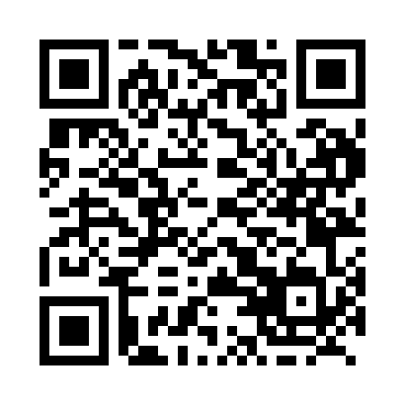
Prayer times for Frances Lake, Yukon, Canada
Wed 1 May 2024 - Fri 31 May 2024
High Latitude Method: Angle Based Rule
Prayer Calculation Method: Islamic Society of North America
Asar Calculation Method: Hanafi

Date | Day | Fajr | Sunrise | Dhuhr | Asr | Maghrib | Isha
1 | Wed | 3:30 | 5:26 | 1:34 | 6:55 | 9:44 | 11:40
2 | Thu | 3:29 | 5:23 | 1:34 | 6:56 | 9:47 | 11:41
3 | Fri | 3:27 | 5:20 | 1:34 | 6:58 | 9:50 | 11:42
4 | Sat | 3:26 | 5:17 | 1:34 | 6:59 | 9:52 | 11:43
5 | Sun | 3:24 | 5:14 | 1:34 | 7:01 | 9:55 | 11:45
6 | Mon | 3:23 | 5:12 | 1:34 | 7:02 | 9:58 | 11:46
7 | Tue | 3:22 | 5:09 | 1:34 | 7:03 | 10:00 | 11:47
8 | Wed | 3:20 | 5:06 | 1:34 | 7:05 | 10:03 | 11:49
9 | Thu | 3:19 | 5:03 | 1:34 | 7:06 | 10:05 | 11:50
10 | Fri | 3:17 | 5:01 | 1:34 | 7:08 | 10:08 | 11:51
11 | Sat | 3:16 | 4:58 | 1:34 | 7:09 | 10:11 | 11:53
12 | Sun | 3:15 | 4:55 | 1:34 | 7:10 | 10:13 | 11:54
13 | Mon | 3:14 | 4:53 | 1:34 | 7:12 | 10:16 | 11:55
14 | Tue | 3:12 | 4:50 | 1:34 | 7:13 | 10:18 | 11:56
15 | Wed | 3:11 | 4:48 | 1:34 | 7:14 | 10:21 | 11:58
16 | Thu | 3:10 | 4:45 | 1:34 | 7:16 | 10:24 | 11:59
17 | Fri | 3:08 | 4:43 | 1:34 | 7:17 | 10:26 | 12:00
18 | Sat | 3:07 | 4:40 | 1:34 | 7:18 | 10:29 | 12:02
19 | Sun | 3:06 | 4:38 | 1:34 | 7:20 | 10:31 | 12:03
20 | Mon | 3:05 | 4:35 | 1:34 | 7:21 | 10:34 | 12:04
21 | Tue | 3:04 | 4:33 | 1:34 | 7:22 | 10:36 | 12:05
22 | Wed | 3:03 | 4:31 | 1:34 | 7:23 | 10:38 | 12:06
23 | Thu | 3:02 | 4:29 | 1:34 | 7:24 | 10:41 | 12:08
24 | Fri | 3:01 | 4:27 | 1:34 | 7:25 | 10:43 | 12:09
25 | Sat | 3:00 | 4:25 | 1:34 | 7:27 | 10:45 | 12:10
26 | Sun | 2:59 | 4:22 | 1:34 | 7:28 | 10:47 | 12:11
27 | Mon | 2:58 | 4:21 | 1:35 | 7:29 | 10:50 | 12:12
28 | Tue | 2:57 | 4:19 | 1:35 | 7:30 | 10:52 | 12:14
29 | Wed | 2:56 | 4:17 | 1:35 | 7:31 | 10:54 | 12:15
30 | Thu | 2:55 | 4:15 | 1:35 | 7:32 | 10:56 | 12:16
31 | Fri | 2:54 | 4:13 | 1:35 | 7:33 | 10:58 | 12:17
Prayer times provided by https://www.salahtimes.com

