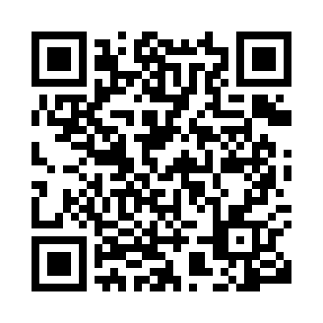
Prayer times for Kelo, Chad
Wed 1 May 2024 - Fri 31 May 2024
High Latitude Method: None
Prayer Calculation Method: Muslim World League
Asar Calculation Method: Shafi

Date | Day | Fajr | Sunrise | Dhuhr | Asr | Maghrib | Isha
1 | Wed | 4:27 | 5:40 | 11:54 | 3:09 | 6:08 | 7:16
2 | Thu | 4:27 | 5:40 | 11:54 | 3:09 | 6:08 | 7:17
3 | Fri | 4:26 | 5:40 | 11:54 | 3:09 | 6:08 | 7:17
4 | Sat | 4:26 | 5:39 | 11:54 | 3:10 | 6:08 | 7:17
5 | Sun | 4:26 | 5:39 | 11:53 | 3:10 | 6:08 | 7:17
6 | Mon | 4:25 | 5:39 | 11:53 | 3:11 | 6:08 | 7:18
7 | Tue | 4:25 | 5:38 | 11:53 | 3:11 | 6:08 | 7:18
8 | Wed | 4:24 | 5:38 | 11:53 | 3:12 | 6:09 | 7:18
9 | Thu | 4:24 | 5:38 | 11:53 | 3:12 | 6:09 | 7:18
10 | Fri | 4:24 | 5:38 | 11:53 | 3:12 | 6:09 | 7:19
11 | Sat | 4:23 | 5:37 | 11:53 | 3:13 | 6:09 | 7:19
12 | Sun | 4:23 | 5:37 | 11:53 | 3:13 | 6:09 | 7:19
13 | Mon | 4:23 | 5:37 | 11:53 | 3:13 | 6:09 | 7:19
14 | Tue | 4:22 | 5:37 | 11:53 | 3:14 | 6:10 | 7:20
15 | Wed | 4:22 | 5:37 | 11:53 | 3:14 | 6:10 | 7:20
16 | Thu | 4:22 | 5:37 | 11:53 | 3:15 | 6:10 | 7:20
17 | Fri | 4:21 | 5:36 | 11:53 | 3:15 | 6:10 | 7:21
18 | Sat | 4:21 | 5:36 | 11:53 | 3:15 | 6:10 | 7:21
19 | Sun | 4:21 | 5:36 | 11:53 | 3:16 | 6:11 | 7:21
20 | Mon | 4:21 | 5:36 | 11:53 | 3:16 | 6:11 | 7:22
21 | Tue | 4:21 | 5:36 | 11:53 | 3:16 | 6:11 | 7:22
22 | Wed | 4:20 | 5:36 | 11:54 | 3:17 | 6:11 | 7:22
23 | Thu | 4:20 | 5:36 | 11:54 | 3:17 | 6:11 | 7:23
24 | Fri | 4:20 | 5:36 | 11:54 | 3:17 | 6:12 | 7:23
25 | Sat | 4:20 | 5:36 | 11:54 | 3:18 | 6:12 | 7:23
26 | Sun | 4:20 | 5:36 | 11:54 | 3:18 | 6:12 | 7:24
27 | Mon | 4:20 | 5:36 | 11:54 | 3:19 | 6:12 | 7:24
28 | Tue | 4:20 | 5:36 | 11:54 | 3:19 | 6:13 | 7:24
29 | Wed | 4:19 | 5:36 | 11:54 | 3:19 | 6:13 | 7:25
30 | Thu | 4:19 | 5:36 | 11:54 | 3:20 | 6:13 | 7:25
31 | Fri | 4:19 | 5:36 | 11:55 | 3:20 | 6:13 | 7:25
Prayer times provided by https://www.salahtimes.com

