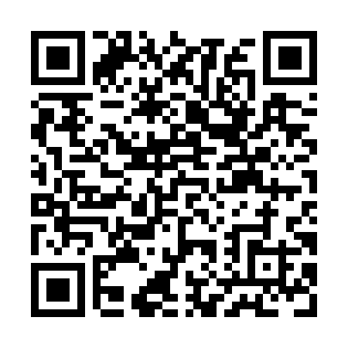
Prayer times for Apamitaukasich, Quebec, Canada
Wed 1 May 2024 - Fri 31 May 2024
High Latitude Method: Angle Based Rule
Prayer Calculation Method: Islamic Society of North America
Asar Calculation Method: Hanafi

Date | Day | Fajr | Sunrise | Dhuhr | Asr | Maghrib | Isha
1 | Wed | 3:09 | 5:18 | 1:00 | 6:12 | 8:43 | 10:52
2 | Thu | 3:08 | 5:15 | 1:00 | 6:14 | 8:45 | 10:53
3 | Fri | 3:07 | 5:13 | 1:00 | 6:15 | 8:47 | 10:54
4 | Sat | 3:05 | 5:11 | 12:59 | 6:16 | 8:49 | 10:54
5 | Sun | 3:04 | 5:09 | 12:59 | 6:17 | 8:51 | 10:55
6 | Mon | 3:03 | 5:07 | 12:59 | 6:18 | 8:53 | 10:56
7 | Tue | 3:02 | 5:05 | 12:59 | 6:20 | 8:55 | 10:57
8 | Wed | 3:01 | 5:02 | 12:59 | 6:21 | 8:57 | 10:58
9 | Thu | 3:00 | 5:00 | 12:59 | 6:22 | 8:59 | 10:59
10 | Fri | 2:59 | 4:58 | 12:59 | 6:23 | 9:01 | 11:00
11 | Sat | 2:58 | 4:56 | 12:59 | 6:24 | 9:03 | 11:01
12 | Sun | 2:57 | 4:55 | 12:59 | 6:25 | 9:05 | 11:02
13 | Mon | 2:56 | 4:53 | 12:59 | 6:26 | 9:06 | 11:03
14 | Tue | 2:55 | 4:51 | 12:59 | 6:27 | 9:08 | 11:04
15 | Wed | 2:54 | 4:49 | 12:59 | 6:28 | 9:10 | 11:05
16 | Thu | 2:53 | 4:47 | 12:59 | 6:29 | 9:12 | 11:06
17 | Fri | 2:52 | 4:45 | 12:59 | 6:30 | 9:14 | 11:07
18 | Sat | 2:52 | 4:44 | 12:59 | 6:31 | 9:16 | 11:08
19 | Sun | 2:51 | 4:42 | 12:59 | 6:32 | 9:17 | 11:08
20 | Mon | 2:50 | 4:40 | 12:59 | 6:33 | 9:19 | 11:09
21 | Tue | 2:49 | 4:39 | 12:59 | 6:34 | 9:21 | 11:10
22 | Wed | 2:49 | 4:37 | 12:59 | 6:35 | 9:22 | 11:11
23 | Thu | 2:48 | 4:36 | 1:00 | 6:36 | 9:24 | 11:12
24 | Fri | 2:47 | 4:34 | 1:00 | 6:37 | 9:26 | 11:13
25 | Sat | 2:46 | 4:33 | 1:00 | 6:38 | 9:27 | 11:14
26 | Sun | 2:46 | 4:31 | 1:00 | 6:39 | 9:29 | 11:15
27 | Mon | 2:45 | 4:30 | 1:00 | 6:40 | 9:30 | 11:15
28 | Tue | 2:45 | 4:29 | 1:00 | 6:41 | 9:32 | 11:16
29 | Wed | 2:44 | 4:28 | 1:00 | 6:41 | 9:33 | 11:17
30 | Thu | 2:44 | 4:27 | 1:00 | 6:42 | 9:35 | 11:18
31 | Fri | 2:43 | 4:25 | 1:01 | 6:43 | 9:36 | 11:18
Prayer times provided by https://www.salahtimes.com

