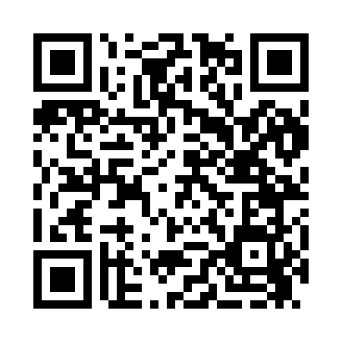
Prayer times for Crary Mills, New York, USA
Wed 1 May 2024 - Fri 31 May 2024
High Latitude Method: Angle Based Rule
Prayer Calculation Method: Islamic Society of North America
Asar Calculation Method: Shafi

Date | Day | Fajr | Sunrise | Dhuhr | Asr | Maghrib | Isha
1 | Wed | 4:16 | 5:50 | 12:57 | 4:53 | 8:06 | 9:39
2 | Thu | 4:14 | 5:48 | 12:57 | 4:54 | 8:07 | 9:41
3 | Fri | 4:13 | 5:47 | 12:57 | 4:54 | 8:08 | 9:43
4 | Sat | 4:11 | 5:45 | 12:57 | 4:54 | 8:09 | 9:44
5 | Sun | 4:09 | 5:44 | 12:57 | 4:55 | 8:10 | 9:46
6 | Mon | 4:07 | 5:43 | 12:57 | 4:55 | 8:12 | 9:48
7 | Tue | 4:05 | 5:41 | 12:57 | 4:56 | 8:13 | 9:50
8 | Wed | 4:03 | 5:40 | 12:57 | 4:56 | 8:14 | 9:51
9 | Thu | 4:01 | 5:39 | 12:57 | 4:56 | 8:15 | 9:53
10 | Fri | 4:00 | 5:38 | 12:57 | 4:57 | 8:16 | 9:55
11 | Sat | 3:58 | 5:36 | 12:57 | 4:57 | 8:17 | 9:56
12 | Sun | 3:56 | 5:35 | 12:57 | 4:58 | 8:19 | 9:58
13 | Mon | 3:54 | 5:34 | 12:57 | 4:58 | 8:20 | 10:00
14 | Tue | 3:53 | 5:33 | 12:57 | 4:58 | 8:21 | 10:01
15 | Wed | 3:51 | 5:32 | 12:57 | 4:59 | 8:22 | 10:03
16 | Thu | 3:49 | 5:31 | 12:57 | 4:59 | 8:23 | 10:05
17 | Fri | 3:48 | 5:30 | 12:57 | 5:00 | 8:24 | 10:06
18 | Sat | 3:46 | 5:29 | 12:57 | 5:00 | 8:25 | 10:08
19 | Sun | 3:45 | 5:28 | 12:57 | 5:00 | 8:26 | 10:10
20 | Mon | 3:43 | 5:27 | 12:57 | 5:01 | 8:27 | 10:11
21 | Tue | 3:42 | 5:26 | 12:57 | 5:01 | 8:28 | 10:13
22 | Wed | 3:40 | 5:25 | 12:57 | 5:01 | 8:30 | 10:15
23 | Thu | 3:39 | 5:24 | 12:57 | 5:02 | 8:31 | 10:16
24 | Fri | 3:38 | 5:23 | 12:57 | 5:02 | 8:32 | 10:18
25 | Sat | 3:36 | 5:23 | 12:57 | 5:03 | 8:32 | 10:19
26 | Sun | 3:35 | 5:22 | 12:57 | 5:03 | 8:33 | 10:21
27 | Mon | 3:34 | 5:21 | 12:58 | 5:03 | 8:34 | 10:22
28 | Tue | 3:32 | 5:20 | 12:58 | 5:04 | 8:35 | 10:24
29 | Wed | 3:31 | 5:20 | 12:58 | 5:04 | 8:36 | 10:25
30 | Thu | 3:30 | 5:19 | 12:58 | 5:04 | 8:37 | 10:26
31 | Fri | 3:29 | 5:19 | 12:58 | 5:05 | 8:38 | 10:28
Prayer times provided by https://www.salahtimes.com

