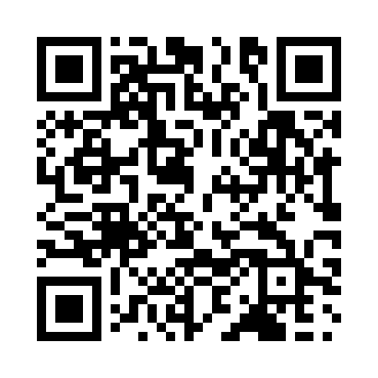
Prayer times for Bla, Cameroon
Mon 1 Apr 2024 - Tue 30 Apr 2024
High Latitude Method: None
Prayer Calculation Method: Muslim World League
Asar Calculation Method: Shafi

Date | Day | Fajr | Sunrise | Dhuhr | Asr | Maghrib | Isha
1 | Mon | 4:46 | 5:57 | 12:03 | 3:15 | 6:11 | 7:17
2 | Tue | 4:46 | 5:56 | 12:03 | 3:15 | 6:11 | 7:17
3 | Wed | 4:45 | 5:55 | 12:03 | 3:14 | 6:11 | 7:17
4 | Thu | 4:44 | 5:55 | 12:03 | 3:13 | 6:11 | 7:17
5 | Fri | 4:44 | 5:54 | 12:02 | 3:12 | 6:11 | 7:17
6 | Sat | 4:43 | 5:54 | 12:02 | 3:12 | 6:11 | 7:17
7 | Sun | 4:42 | 5:53 | 12:02 | 3:11 | 6:11 | 7:17
8 | Mon | 4:42 | 5:52 | 12:01 | 3:10 | 6:11 | 7:17
9 | Tue | 4:41 | 5:52 | 12:01 | 3:09 | 6:11 | 7:18
10 | Wed | 4:40 | 5:51 | 12:01 | 3:08 | 6:11 | 7:18
11 | Thu | 4:40 | 5:51 | 12:01 | 3:08 | 6:11 | 7:18
12 | Fri | 4:39 | 5:50 | 12:00 | 3:07 | 6:11 | 7:18
13 | Sat | 4:38 | 5:50 | 12:00 | 3:06 | 6:11 | 7:18
14 | Sun | 4:38 | 5:49 | 12:00 | 3:05 | 6:11 | 7:18
15 | Mon | 4:37 | 5:49 | 12:00 | 3:04 | 6:11 | 7:18
16 | Tue | 4:36 | 5:48 | 11:59 | 3:04 | 6:11 | 7:18
17 | Wed | 4:36 | 5:48 | 11:59 | 3:03 | 6:11 | 7:19
18 | Thu | 4:35 | 5:47 | 11:59 | 3:03 | 6:11 | 7:19
19 | Fri | 4:35 | 5:47 | 11:59 | 3:04 | 6:11 | 7:19
20 | Sat | 4:34 | 5:46 | 11:59 | 3:04 | 6:11 | 7:19
21 | Sun | 4:33 | 5:46 | 11:58 | 3:05 | 6:11 | 7:19
22 | Mon | 4:33 | 5:45 | 11:58 | 3:05 | 6:11 | 7:19
23 | Tue | 4:32 | 5:45 | 11:58 | 3:06 | 6:11 | 7:20
24 | Wed | 4:32 | 5:44 | 11:58 | 3:06 | 6:12 | 7:20
25 | Thu | 4:31 | 5:44 | 11:58 | 3:07 | 6:12 | 7:20
26 | Fri | 4:31 | 5:43 | 11:57 | 3:07 | 6:12 | 7:20
27 | Sat | 4:30 | 5:43 | 11:57 | 3:08 | 6:12 | 7:21
28 | Sun | 4:30 | 5:43 | 11:57 | 3:09 | 6:12 | 7:21
29 | Mon | 4:29 | 5:42 | 11:57 | 3:09 | 6:12 | 7:21
30 | Tue | 4:29 | 5:42 | 11:57 | 3:09 | 6:12 | 7:21
Prayer times provided by https://www.salahtimes.com

