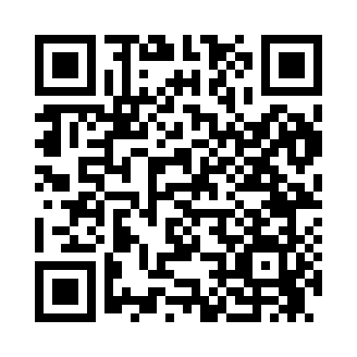
Prayer times for Buffalo, New York, USA
Mon 1 Apr 2024 - Tue 30 Apr 2024
High Latitude Method: Angle Based Rule
Prayer Calculation Method: Islamic Society of North America
Asar Calculation Method: Shafi

Date | Day | Fajr | Sunrise | Dhuhr | Asr | Maghrib | Isha
1 | Mon | 5:37 | 6:57 | 1:19 | 4:54 | 7:42 | 9:02
2 | Tue | 5:35 | 6:55 | 1:19 | 4:55 | 7:43 | 9:04
3 | Wed | 5:33 | 6:53 | 1:18 | 4:55 | 7:45 | 9:05
4 | Thu | 5:31 | 6:51 | 1:18 | 4:56 | 7:46 | 9:07
5 | Fri | 5:29 | 6:50 | 1:18 | 4:56 | 7:47 | 9:08
6 | Sat | 5:27 | 6:48 | 1:18 | 4:57 | 7:48 | 9:09
7 | Sun | 5:25 | 6:46 | 1:17 | 4:57 | 7:49 | 9:11
8 | Mon | 5:23 | 6:44 | 1:17 | 4:58 | 7:50 | 9:12
9 | Tue | 5:21 | 6:43 | 1:17 | 4:58 | 7:52 | 9:14
10 | Wed | 5:19 | 6:41 | 1:17 | 4:58 | 7:53 | 9:15
11 | Thu | 5:17 | 6:39 | 1:16 | 4:59 | 7:54 | 9:16
12 | Fri | 5:15 | 6:38 | 1:16 | 4:59 | 7:55 | 9:18
13 | Sat | 5:13 | 6:36 | 1:16 | 5:00 | 7:56 | 9:19
14 | Sun | 5:11 | 6:34 | 1:16 | 5:00 | 7:57 | 9:21
15 | Mon | 5:09 | 6:33 | 1:15 | 5:01 | 7:58 | 9:22
16 | Tue | 5:07 | 6:31 | 1:15 | 5:01 | 8:00 | 9:24
17 | Wed | 5:05 | 6:30 | 1:15 | 5:01 | 8:01 | 9:25
18 | Thu | 5:03 | 6:28 | 1:15 | 5:02 | 8:02 | 9:27
19 | Fri | 5:01 | 6:26 | 1:14 | 5:02 | 8:03 | 9:28
20 | Sat | 5:00 | 6:25 | 1:14 | 5:02 | 8:04 | 9:30
21 | Sun | 4:58 | 6:23 | 1:14 | 5:03 | 8:05 | 9:31
22 | Mon | 4:56 | 6:22 | 1:14 | 5:03 | 8:07 | 9:33
23 | Tue | 4:54 | 6:20 | 1:14 | 5:04 | 8:08 | 9:34
24 | Wed | 4:52 | 6:19 | 1:13 | 5:04 | 8:09 | 9:36
25 | Thu | 4:50 | 6:17 | 1:13 | 5:04 | 8:10 | 9:37
26 | Fri | 4:48 | 6:16 | 1:13 | 5:05 | 8:11 | 9:39
27 | Sat | 4:46 | 6:14 | 1:13 | 5:05 | 8:12 | 9:40
28 | Sun | 4:45 | 6:13 | 1:13 | 5:05 | 8:13 | 9:42
29 | Mon | 4:43 | 6:11 | 1:13 | 5:06 | 8:15 | 9:44
30 | Tue | 4:41 | 6:10 | 1:13 | 5:06 | 8:16 | 9:45
Prayer times provided by https://www.salahtimes.com

