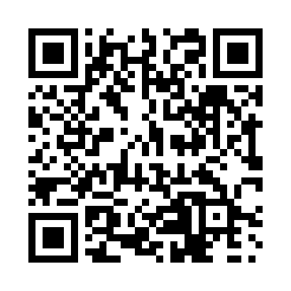
Prayer times for McQuesten, Yukon, Canada
Wed 1 May 2024 - Fri 31 May 2024
High Latitude Method: Angle Based Rule
Prayer Calculation Method: Islamic Society of North America
Asar Calculation Method: Hanafi

Date | Day | Fajr | Sunrise | Dhuhr | Asr | Maghrib | Isha
1 | Wed | 3:55 | 5:43 | 2:07 | 7:31 | 10:32 | 12:20
2 | Thu | 3:54 | 5:40 | 2:07 | 7:32 | 10:35 | 12:21
3 | Fri | 3:52 | 5:37 | 2:06 | 7:34 | 10:38 | 12:23
4 | Sat | 3:50 | 5:33 | 2:06 | 7:36 | 10:41 | 12:24
5 | Sun | 3:49 | 5:30 | 2:06 | 7:37 | 10:44 | 12:26
6 | Mon | 3:47 | 5:27 | 2:06 | 7:39 | 10:47 | 12:27
7 | Tue | 3:45 | 5:24 | 2:06 | 7:40 | 10:50 | 12:29
8 | Wed | 3:44 | 5:20 | 2:06 | 7:42 | 10:53 | 12:30
9 | Thu | 3:42 | 5:17 | 2:06 | 7:44 | 10:57 | 12:32
10 | Fri | 3:40 | 5:14 | 2:06 | 7:45 | 11:00 | 12:33
11 | Sat | 3:39 | 5:11 | 2:06 | 7:47 | 11:03 | 12:35
12 | Sun | 3:37 | 5:08 | 2:06 | 7:48 | 11:06 | 12:36
13 | Mon | 3:36 | 5:05 | 2:06 | 7:50 | 11:09 | 12:38
14 | Tue | 3:34 | 5:02 | 2:06 | 7:51 | 11:12 | 12:39
15 | Wed | 3:33 | 4:59 | 2:06 | 7:53 | 11:15 | 12:41
16 | Thu | 3:31 | 4:55 | 2:06 | 7:54 | 11:18 | 12:42
17 | Fri | 3:30 | 4:52 | 2:06 | 7:56 | 11:21 | 12:44
18 | Sat | 3:28 | 4:50 | 2:06 | 7:57 | 11:24 | 12:46
19 | Sun | 3:27 | 4:47 | 2:06 | 7:58 | 11:27 | 12:47
20 | Mon | 3:25 | 4:44 | 2:06 | 8:00 | 11:30 | 12:49
21 | Tue | 3:24 | 4:41 | 2:06 | 8:01 | 11:33 | 12:50
22 | Wed | 3:23 | 4:38 | 2:06 | 8:02 | 11:36 | 12:52
23 | Thu | 3:21 | 4:35 | 2:06 | 8:03 | 11:39 | 12:53
24 | Fri | 3:20 | 4:33 | 2:07 | 8:05 | 11:42 | 12:55
25 | Sat | 3:19 | 4:30 | 2:07 | 8:06 | 11:45 | 12:56
26 | Sun | 3:17 | 4:27 | 2:07 | 8:07 | 11:48 | 12:58
27 | Mon | 3:16 | 4:25 | 2:07 | 8:08 | 11:51 | 12:59
28 | Tue | 3:15 | 4:22 | 2:07 | 8:09 | 11:53 | 1:01
29 | Wed | 3:14 | 4:20 | 2:07 | 8:10 | 11:56 | 1:02
30 | Thu | 3:13 | 4:17 | 2:07 | 8:11 | 11:59 | 1:03
31 | Fri | 3:12 | 4:15 | 2:07 | 8:12 | 12:01 | 1:05
Prayer times provided by https://www.salahtimes.com

