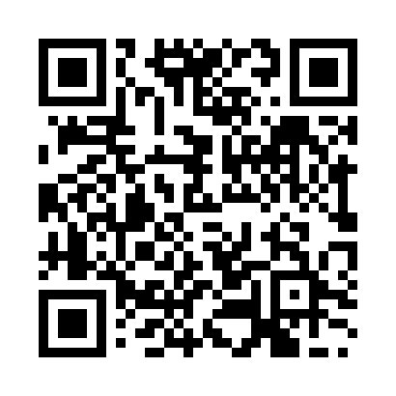
Prayer times for Rebun Island, Japan
Wed 1 May 2024 - Fri 31 May 2024
High Latitude Method: None
Prayer Calculation Method: Muslim World League
Asar Calculation Method: Shafi

Date | Day | Fajr | Sunrise | Dhuhr | Asr | Maghrib | Isha
1 | Wed | 2:26 | 4:24 | 11:33 | 3:30 | 6:42 | 8:33
2 | Thu | 2:24 | 4:23 | 11:33 | 3:30 | 6:44 | 8:35
3 | Fri | 2:21 | 4:21 | 11:33 | 3:30 | 6:45 | 8:37
4 | Sat | 2:19 | 4:20 | 11:33 | 3:31 | 6:46 | 8:39
5 | Sun | 2:17 | 4:19 | 11:33 | 3:31 | 6:47 | 8:41
6 | Mon | 2:15 | 4:17 | 11:33 | 3:32 | 6:49 | 8:43
7 | Tue | 2:13 | 4:16 | 11:32 | 3:32 | 6:50 | 8:45
8 | Wed | 2:10 | 4:15 | 11:32 | 3:33 | 6:51 | 8:47
9 | Thu | 2:08 | 4:13 | 11:32 | 3:33 | 6:52 | 8:49
10 | Fri | 2:06 | 4:12 | 11:32 | 3:33 | 6:53 | 8:51
11 | Sat | 2:04 | 4:11 | 11:32 | 3:34 | 6:55 | 8:53
12 | Sun | 2:02 | 4:09 | 11:32 | 3:34 | 6:56 | 8:55
13 | Mon | 2:00 | 4:08 | 11:32 | 3:35 | 6:57 | 8:57
14 | Tue | 1:58 | 4:07 | 11:32 | 3:35 | 6:58 | 8:59
15 | Wed | 1:55 | 4:06 | 11:32 | 3:35 | 6:59 | 9:01
16 | Thu | 1:53 | 4:05 | 11:32 | 3:36 | 7:01 | 9:03
17 | Fri | 1:51 | 4:04 | 11:32 | 3:36 | 7:02 | 9:05
18 | Sat | 1:49 | 4:03 | 11:32 | 3:37 | 7:03 | 9:06
19 | Sun | 1:47 | 4:02 | 11:32 | 3:37 | 7:04 | 9:08
20 | Mon | 1:45 | 4:01 | 11:32 | 3:37 | 7:05 | 9:10
21 | Tue | 1:44 | 4:00 | 11:33 | 3:38 | 7:06 | 9:12
22 | Wed | 1:42 | 3:59 | 11:33 | 3:38 | 7:07 | 9:14
23 | Thu | 1:40 | 3:58 | 11:33 | 3:39 | 7:08 | 9:16
24 | Fri | 1:38 | 3:57 | 11:33 | 3:39 | 7:09 | 9:18
25 | Sat | 1:36 | 3:56 | 11:33 | 3:39 | 7:10 | 9:20
26 | Sun | 1:34 | 3:55 | 11:33 | 3:40 | 7:11 | 9:21
27 | Mon | 1:33 | 3:54 | 11:33 | 3:40 | 7:12 | 9:23
28 | Tue | 1:31 | 3:54 | 11:33 | 3:40 | 7:13 | 9:25
29 | Wed | 1:29 | 3:53 | 11:33 | 3:41 | 7:14 | 9:27
30 | Thu | 1:28 | 3:52 | 11:34 | 3:41 | 7:15 | 9:28
31 | Fri | 1:26 | 3:52 | 11:34 | 3:42 | 7:16 | 9:30
Prayer times provided by https://www.salahtimes.com

