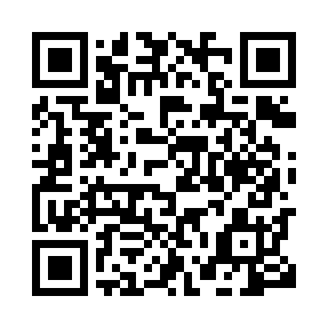
Prayer times for Blame, Cameroon
Wed 1 May 2024 - Fri 31 May 2024
High Latitude Method: None
Prayer Calculation Method: Muslim World League
Asar Calculation Method: Shafi

Date | Day | Fajr | Sunrise | Dhuhr | Asr | Maghrib | Isha
1 | Wed | 4:28 | 5:42 | 11:59 | 3:10 | 6:16 | 7:26
2 | Thu | 4:27 | 5:41 | 11:59 | 3:11 | 6:16 | 7:26
3 | Fri | 4:27 | 5:41 | 11:59 | 3:11 | 6:16 | 7:26
4 | Sat | 4:26 | 5:40 | 11:58 | 3:12 | 6:17 | 7:27
5 | Sun | 4:26 | 5:40 | 11:58 | 3:12 | 6:17 | 7:27
6 | Mon | 4:25 | 5:40 | 11:58 | 3:13 | 6:17 | 7:27
7 | Tue | 4:25 | 5:39 | 11:58 | 3:13 | 6:17 | 7:28
8 | Wed | 4:24 | 5:39 | 11:58 | 3:14 | 6:17 | 7:28
9 | Thu | 4:24 | 5:39 | 11:58 | 3:14 | 6:18 | 7:28
10 | Fri | 4:23 | 5:38 | 11:58 | 3:15 | 6:18 | 7:29
11 | Sat | 4:23 | 5:38 | 11:58 | 3:15 | 6:18 | 7:29
12 | Sun | 4:22 | 5:38 | 11:58 | 3:16 | 6:18 | 7:29
13 | Mon | 4:22 | 5:38 | 11:58 | 3:16 | 6:19 | 7:30
14 | Tue | 4:22 | 5:37 | 11:58 | 3:17 | 6:19 | 7:30
15 | Wed | 4:21 | 5:37 | 11:58 | 3:17 | 6:19 | 7:31
16 | Thu | 4:21 | 5:37 | 11:58 | 3:17 | 6:19 | 7:31
17 | Fri | 4:21 | 5:37 | 11:58 | 3:18 | 6:20 | 7:31
18 | Sat | 4:20 | 5:37 | 11:58 | 3:18 | 6:20 | 7:32
19 | Sun | 4:20 | 5:36 | 11:58 | 3:19 | 6:20 | 7:32
20 | Mon | 4:20 | 5:36 | 11:58 | 3:19 | 6:20 | 7:32
21 | Tue | 4:20 | 5:36 | 11:58 | 3:20 | 6:21 | 7:33
22 | Wed | 4:19 | 5:36 | 11:58 | 3:20 | 6:21 | 7:33
23 | Thu | 4:19 | 5:36 | 11:59 | 3:20 | 6:21 | 7:34
24 | Fri | 4:19 | 5:36 | 11:59 | 3:21 | 6:22 | 7:34
25 | Sat | 4:19 | 5:36 | 11:59 | 3:21 | 6:22 | 7:34
26 | Sun | 4:18 | 5:36 | 11:59 | 3:22 | 6:22 | 7:35
27 | Mon | 4:18 | 5:36 | 11:59 | 3:22 | 6:22 | 7:35
28 | Tue | 4:18 | 5:36 | 11:59 | 3:23 | 6:23 | 7:36
29 | Wed | 4:18 | 5:36 | 11:59 | 3:23 | 6:23 | 7:36
30 | Thu | 4:18 | 5:36 | 11:59 | 3:23 | 6:23 | 7:36
31 | Fri | 4:18 | 5:36 | 11:59 | 3:24 | 6:24 | 7:37
Prayer times provided by https://www.salahtimes.com

