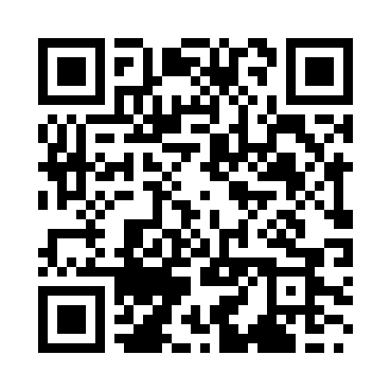
Prayer times for Zvecan, Kosovo
Mon 1 Jul 2024 - Wed 31 Jul 2024
High Latitude Method: None
Prayer Calculation Method: Muslim World League
Asar Calculation Method: Shafi

Date | Day | Fajr | Sunrise | Dhuhr | Asr | Maghrib | Isha
1 | Mon | 2:46 | 5:02 | 12:41 | 4:45 | 8:19 | 10:25
2 | Tue | 2:47 | 5:02 | 12:41 | 4:45 | 8:19 | 10:24
3 | Wed | 2:48 | 5:03 | 12:41 | 4:45 | 8:19 | 10:24
4 | Thu | 2:49 | 5:04 | 12:41 | 4:45 | 8:19 | 10:23
5 | Fri | 2:50 | 5:04 | 12:41 | 4:45 | 8:18 | 10:22
6 | Sat | 2:51 | 5:05 | 12:42 | 4:45 | 8:18 | 10:21
7 | Sun | 2:52 | 5:06 | 12:42 | 4:46 | 8:18 | 10:21
8 | Mon | 2:53 | 5:06 | 12:42 | 4:46 | 8:17 | 10:20
9 | Tue | 2:55 | 5:07 | 12:42 | 4:46 | 8:17 | 10:19
10 | Wed | 2:56 | 5:08 | 12:42 | 4:46 | 8:16 | 10:18
11 | Thu | 2:57 | 5:08 | 12:42 | 4:45 | 8:16 | 10:17
12 | Fri | 2:59 | 5:09 | 12:42 | 4:45 | 8:15 | 10:16
13 | Sat | 3:00 | 5:10 | 12:42 | 4:45 | 8:15 | 10:15
14 | Sun | 3:01 | 5:11 | 12:43 | 4:45 | 8:14 | 10:13
15 | Mon | 3:03 | 5:12 | 12:43 | 4:45 | 8:13 | 10:12
16 | Tue | 3:04 | 5:13 | 12:43 | 4:45 | 8:13 | 10:11
17 | Wed | 3:06 | 5:13 | 12:43 | 4:45 | 8:12 | 10:10
18 | Thu | 3:08 | 5:14 | 12:43 | 4:45 | 8:11 | 10:08
19 | Fri | 3:09 | 5:15 | 12:43 | 4:45 | 8:10 | 10:07
20 | Sat | 3:11 | 5:16 | 12:43 | 4:44 | 8:09 | 10:06
21 | Sun | 3:12 | 5:17 | 12:43 | 4:44 | 8:09 | 10:04
22 | Mon | 3:14 | 5:18 | 12:43 | 4:44 | 8:08 | 10:03
23 | Tue | 3:16 | 5:19 | 12:43 | 4:44 | 8:07 | 10:01
24 | Wed | 3:17 | 5:20 | 12:43 | 4:44 | 8:06 | 10:00
25 | Thu | 3:19 | 5:21 | 12:43 | 4:43 | 8:05 | 9:58
26 | Fri | 3:21 | 5:22 | 12:43 | 4:43 | 8:04 | 9:56
27 | Sat | 3:22 | 5:23 | 12:43 | 4:43 | 8:03 | 9:55
28 | Sun | 3:24 | 5:24 | 12:43 | 4:42 | 8:02 | 9:53
29 | Mon | 3:26 | 5:25 | 12:43 | 4:42 | 8:01 | 9:51
30 | Tue | 3:27 | 5:26 | 12:43 | 4:42 | 8:00 | 9:50
31 | Wed | 3:29 | 5:27 | 12:43 | 4:41 | 7:58 | 9:48
Prayer times provided by https://www.salahtimes.com

