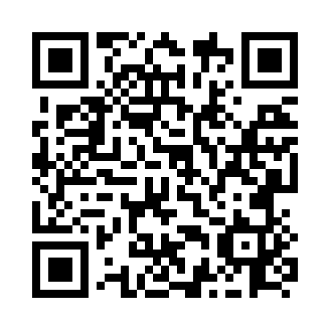
Prayer times for Twomey, Alberta, Canada
Mon 1 Apr 2024 - Tue 30 Apr 2024
High Latitude Method: Angle Based Rule
Prayer Calculation Method: Islamic Society of North America
Asar Calculation Method: Hanafi

Date | Day | Fajr | Sunrise | Dhuhr | Asr | Maghrib | Isha
1 | Mon | 5:23 | 7:03 | 1:35 | 6:02 | 8:07 | 9:48
2 | Tue | 5:20 | 7:01 | 1:34 | 6:03 | 8:09 | 9:50
3 | Wed | 5:17 | 6:58 | 1:34 | 6:04 | 8:11 | 9:52
4 | Thu | 5:14 | 6:56 | 1:34 | 6:05 | 8:12 | 9:54
5 | Fri | 5:11 | 6:54 | 1:33 | 6:07 | 8:14 | 9:57
6 | Sat | 5:09 | 6:51 | 1:33 | 6:08 | 8:16 | 9:59
7 | Sun | 5:06 | 6:49 | 1:33 | 6:09 | 8:18 | 10:01
8 | Mon | 5:03 | 6:47 | 1:33 | 6:11 | 8:20 | 10:04
9 | Tue | 5:00 | 6:44 | 1:32 | 6:12 | 8:21 | 10:06
10 | Wed | 4:57 | 6:42 | 1:32 | 6:13 | 8:23 | 10:09
11 | Thu | 4:54 | 6:40 | 1:32 | 6:14 | 8:25 | 10:11
12 | Fri | 4:51 | 6:37 | 1:32 | 6:15 | 8:27 | 10:14
13 | Sat | 4:48 | 6:35 | 1:31 | 6:17 | 8:28 | 10:16
14 | Sun | 4:45 | 6:33 | 1:31 | 6:18 | 8:30 | 10:19
15 | Mon | 4:42 | 6:31 | 1:31 | 6:19 | 8:32 | 10:21
16 | Tue | 4:39 | 6:28 | 1:31 | 6:20 | 8:34 | 10:24
17 | Wed | 4:36 | 6:26 | 1:30 | 6:21 | 8:36 | 10:26
18 | Thu | 4:33 | 6:24 | 1:30 | 6:23 | 8:37 | 10:29
19 | Fri | 4:30 | 6:22 | 1:30 | 6:24 | 8:39 | 10:31
20 | Sat | 4:27 | 6:19 | 1:30 | 6:25 | 8:41 | 10:34
21 | Sun | 4:24 | 6:17 | 1:29 | 6:26 | 8:43 | 10:37
22 | Mon | 4:21 | 6:15 | 1:29 | 6:27 | 8:44 | 10:40
23 | Tue | 4:17 | 6:13 | 1:29 | 6:28 | 8:46 | 10:42
24 | Wed | 4:14 | 6:11 | 1:29 | 6:30 | 8:48 | 10:45
25 | Thu | 4:11 | 6:09 | 1:29 | 6:31 | 8:50 | 10:48
26 | Fri | 4:08 | 6:07 | 1:29 | 6:32 | 8:52 | 10:51
27 | Sat | 4:05 | 6:05 | 1:28 | 6:33 | 8:53 | 10:54
28 | Sun | 4:02 | 6:03 | 1:28 | 6:34 | 8:55 | 10:57
29 | Mon | 3:58 | 6:00 | 1:28 | 6:35 | 8:57 | 11:00
30 | Tue | 3:55 | 5:58 | 1:28 | 6:36 | 8:59 | 11:03
Prayer times provided by https://www.salahtimes.com

