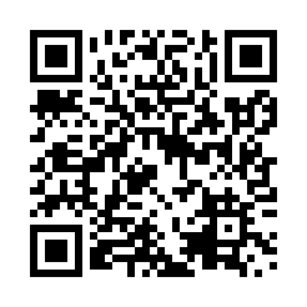
Prayer times for Baker-Brook, New Brunswick, Canada
Wed 1 May 2024 - Fri 31 May 2024
High Latitude Method: Angle Based Rule
Prayer Calculation Method: Islamic Society of North America
Asar Calculation Method: Hanafi

Date | Day | Fajr | Sunrise | Dhuhr | Asr | Maghrib | Isha
1 | Wed | 4:36 | 6:17 | 1:31 | 6:34 | 8:46 | 10:27
2 | Thu | 4:34 | 6:15 | 1:31 | 6:35 | 8:47 | 10:29
3 | Fri | 4:32 | 6:14 | 1:31 | 6:36 | 8:49 | 10:31
4 | Sat | 4:29 | 6:12 | 1:31 | 6:36 | 8:50 | 10:33
5 | Sun | 4:27 | 6:11 | 1:31 | 6:37 | 8:52 | 10:35
6 | Mon | 4:25 | 6:09 | 1:31 | 6:38 | 8:53 | 10:37
7 | Tue | 4:23 | 6:08 | 1:31 | 6:39 | 8:54 | 10:39
8 | Wed | 4:21 | 6:06 | 1:31 | 6:40 | 8:56 | 10:41
9 | Thu | 4:19 | 6:05 | 1:30 | 6:40 | 8:57 | 10:44
10 | Fri | 4:16 | 6:03 | 1:30 | 6:41 | 8:58 | 10:46
11 | Sat | 4:14 | 6:02 | 1:30 | 6:42 | 8:59 | 10:48
12 | Sun | 4:12 | 6:01 | 1:30 | 6:43 | 9:01 | 10:50
13 | Mon | 4:10 | 5:59 | 1:30 | 6:43 | 9:02 | 10:52
14 | Tue | 4:08 | 5:58 | 1:30 | 6:44 | 9:03 | 10:54
15 | Wed | 4:06 | 5:57 | 1:30 | 6:45 | 9:05 | 10:56
16 | Thu | 4:04 | 5:56 | 1:30 | 6:46 | 9:06 | 10:58
17 | Fri | 4:02 | 5:55 | 1:30 | 6:46 | 9:07 | 11:00
18 | Sat | 4:00 | 5:53 | 1:31 | 6:47 | 9:08 | 11:02
19 | Sun | 3:59 | 5:52 | 1:31 | 6:48 | 9:09 | 11:04
20 | Mon | 3:57 | 5:51 | 1:31 | 6:49 | 9:11 | 11:06
21 | Tue | 3:55 | 5:50 | 1:31 | 6:49 | 9:12 | 11:08
22 | Wed | 3:53 | 5:49 | 1:31 | 6:50 | 9:13 | 11:09
23 | Thu | 3:51 | 5:48 | 1:31 | 6:51 | 9:14 | 11:11
24 | Fri | 3:50 | 5:47 | 1:31 | 6:51 | 9:15 | 11:13
25 | Sat | 3:48 | 5:46 | 1:31 | 6:52 | 9:16 | 11:15
26 | Sun | 3:46 | 5:46 | 1:31 | 6:53 | 9:17 | 11:17
27 | Mon | 3:45 | 5:45 | 1:31 | 6:53 | 9:18 | 11:19
28 | Tue | 3:43 | 5:44 | 1:31 | 6:54 | 9:19 | 11:20
29 | Wed | 3:42 | 5:43 | 1:32 | 6:54 | 9:20 | 11:22
30 | Thu | 3:40 | 5:43 | 1:32 | 6:55 | 9:21 | 11:24
31 | Fri | 3:39 | 5:42 | 1:32 | 6:56 | 9:22 | 11:26
Prayer times provided by https://www.salahtimes.com

