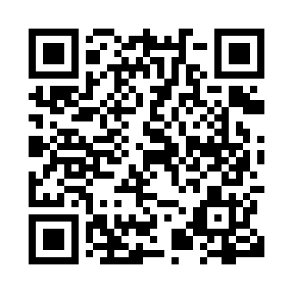
Prayer times for Goshen, New Brunswick, Canada
Wed 1 May 2024 - Fri 31 May 2024
High Latitude Method: Angle Based Rule
Prayer Calculation Method: Islamic Society of North America
Asar Calculation Method: Hanafi

Date | Day | Fajr | Sunrise | Dhuhr | Asr | Maghrib | Isha
1 | Wed | 4:33 | 6:09 | 1:20 | 6:21 | 8:31 | 10:08
2 | Thu | 4:31 | 6:08 | 1:20 | 6:22 | 8:32 | 10:10
3 | Fri | 4:29 | 6:06 | 1:20 | 6:23 | 8:34 | 10:12
4 | Sat | 4:27 | 6:05 | 1:20 | 6:24 | 8:35 | 10:14
5 | Sun | 4:24 | 6:03 | 1:20 | 6:24 | 8:36 | 10:16
6 | Mon | 4:22 | 6:02 | 1:19 | 6:25 | 8:38 | 10:17
7 | Tue | 4:21 | 6:01 | 1:19 | 6:26 | 8:39 | 10:19
8 | Wed | 4:19 | 5:59 | 1:19 | 6:27 | 8:40 | 10:21
9 | Thu | 4:17 | 5:58 | 1:19 | 6:27 | 8:41 | 10:23
10 | Fri | 4:15 | 5:57 | 1:19 | 6:28 | 8:43 | 10:25
11 | Sat | 4:13 | 5:55 | 1:19 | 6:29 | 8:44 | 10:27
12 | Sun | 4:11 | 5:54 | 1:19 | 6:29 | 8:45 | 10:29
13 | Mon | 4:09 | 5:53 | 1:19 | 6:30 | 8:46 | 10:30
14 | Tue | 4:07 | 5:52 | 1:19 | 6:31 | 8:47 | 10:32
15 | Wed | 4:05 | 5:50 | 1:19 | 6:32 | 8:49 | 10:34
16 | Thu | 4:04 | 5:49 | 1:19 | 6:32 | 8:50 | 10:36
17 | Fri | 4:02 | 5:48 | 1:19 | 6:33 | 8:51 | 10:38
18 | Sat | 4:00 | 5:47 | 1:19 | 6:34 | 8:52 | 10:39
19 | Sun | 3:58 | 5:46 | 1:19 | 6:34 | 8:53 | 10:41
20 | Mon | 3:57 | 5:45 | 1:19 | 6:35 | 8:54 | 10:43
21 | Tue | 3:55 | 5:44 | 1:20 | 6:36 | 8:55 | 10:45
22 | Wed | 3:54 | 5:43 | 1:20 | 6:36 | 8:56 | 10:46
23 | Thu | 3:52 | 5:42 | 1:20 | 6:37 | 8:58 | 10:48
24 | Fri | 3:51 | 5:41 | 1:20 | 6:37 | 8:59 | 10:50
25 | Sat | 3:49 | 5:41 | 1:20 | 6:38 | 9:00 | 10:51
26 | Sun | 3:48 | 5:40 | 1:20 | 6:39 | 9:01 | 10:53
27 | Mon | 3:46 | 5:39 | 1:20 | 6:39 | 9:02 | 10:55
28 | Tue | 3:45 | 5:38 | 1:20 | 6:40 | 9:03 | 10:56
29 | Wed | 3:44 | 5:38 | 1:20 | 6:40 | 9:03 | 10:58
30 | Thu | 3:43 | 5:37 | 1:21 | 6:41 | 9:04 | 10:59
31 | Fri | 3:41 | 5:36 | 1:21 | 6:42 | 9:05 | 11:01
Prayer times provided by https://www.salahtimes.com

