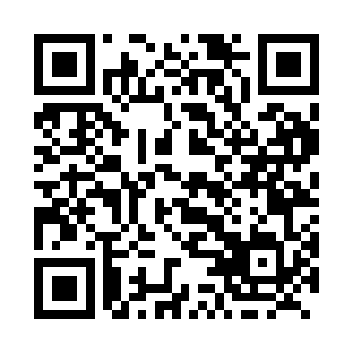
Prayer times for Thunderchild, Saskatchewan, Canada
Wed 1 May 2024 - Fri 31 May 2024
High Latitude Method: Angle Based Rule
Prayer Calculation Method: Islamic Society of North America
Asar Calculation Method: Hanafi

Date | Day | Fajr | Sunrise | Dhuhr | Asr | Maghrib | Isha
1 | Wed | 3:32 | 5:40 | 1:13 | 6:23 | 8:47 | 10:55
2 | Thu | 3:29 | 5:38 | 1:13 | 6:24 | 8:49 | 10:58
3 | Fri | 3:25 | 5:36 | 1:13 | 6:25 | 8:50 | 11:02
4 | Sat | 3:23 | 5:34 | 1:12 | 6:26 | 8:52 | 11:03
5 | Sun | 3:22 | 5:32 | 1:12 | 6:27 | 8:54 | 11:03
6 | Mon | 3:21 | 5:30 | 1:12 | 6:28 | 8:56 | 11:04
7 | Tue | 3:20 | 5:28 | 1:12 | 6:29 | 8:57 | 11:05
8 | Wed | 3:19 | 5:26 | 1:12 | 6:30 | 8:59 | 11:06
9 | Thu | 3:18 | 5:24 | 1:12 | 6:31 | 9:01 | 11:07
10 | Fri | 3:18 | 5:23 | 1:12 | 6:32 | 9:03 | 11:08
11 | Sat | 3:17 | 5:21 | 1:12 | 6:33 | 9:04 | 11:08
12 | Sun | 3:16 | 5:19 | 1:12 | 6:34 | 9:06 | 11:09
13 | Mon | 3:15 | 5:17 | 1:12 | 6:35 | 9:08 | 11:10
14 | Tue | 3:14 | 5:16 | 1:12 | 6:36 | 9:09 | 11:11
15 | Wed | 3:13 | 5:14 | 1:12 | 6:37 | 9:11 | 11:12
16 | Thu | 3:13 | 5:13 | 1:12 | 6:38 | 9:12 | 11:13
17 | Fri | 3:12 | 5:11 | 1:12 | 6:39 | 9:14 | 11:13
18 | Sat | 3:11 | 5:10 | 1:12 | 6:40 | 9:16 | 11:14
19 | Sun | 3:10 | 5:08 | 1:12 | 6:41 | 9:17 | 11:15
20 | Mon | 3:10 | 5:07 | 1:12 | 6:42 | 9:19 | 11:16
21 | Tue | 3:09 | 5:05 | 1:12 | 6:42 | 9:20 | 11:17
22 | Wed | 3:08 | 5:04 | 1:12 | 6:43 | 9:22 | 11:17
23 | Thu | 3:08 | 5:03 | 1:13 | 6:44 | 9:23 | 11:18
24 | Fri | 3:07 | 5:01 | 1:13 | 6:45 | 9:25 | 11:19
25 | Sat | 3:07 | 5:00 | 1:13 | 6:46 | 9:26 | 11:20
26 | Sun | 3:06 | 4:59 | 1:13 | 6:47 | 9:27 | 11:20
27 | Mon | 3:06 | 4:58 | 1:13 | 6:47 | 9:29 | 11:21
28 | Tue | 3:05 | 4:57 | 1:13 | 6:48 | 9:30 | 11:22
29 | Wed | 3:05 | 4:56 | 1:13 | 6:49 | 9:31 | 11:22
30 | Thu | 3:04 | 4:55 | 1:13 | 6:50 | 9:33 | 11:23
31 | Fri | 3:04 | 4:54 | 1:14 | 6:50 | 9:34 | 11:24
Prayer times provided by https://www.salahtimes.com

