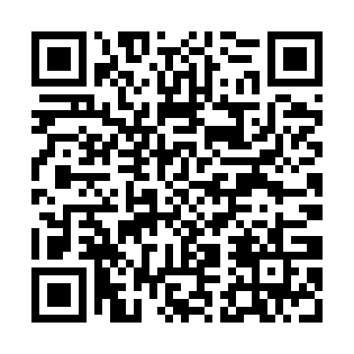
Prayer times for Blekkersvijver, Belgium
Mon 1 Apr 2024 - Tue 30 Apr 2024
High Latitude Method: Angle Based Rule
Prayer Calculation Method: Muslim World League
Asar Calculation Method: Shafi

Date | Day | Fajr | Sunrise | Dhuhr | Asr | Maghrib | Isha
1 | Mon | 5:24 | 7:21 | 1:50 | 5:24 | 8:20 | 10:10
2 | Tue | 5:21 | 7:19 | 1:50 | 5:25 | 8:22 | 10:13
3 | Wed | 5:18 | 7:17 | 1:50 | 5:25 | 8:23 | 10:15
4 | Thu | 5:16 | 7:15 | 1:49 | 5:26 | 8:25 | 10:17
5 | Fri | 5:13 | 7:12 | 1:49 | 5:27 | 8:27 | 10:19
6 | Sat | 5:10 | 7:10 | 1:49 | 5:28 | 8:28 | 10:21
7 | Sun | 5:07 | 7:08 | 1:49 | 5:29 | 8:30 | 10:24
8 | Mon | 5:04 | 7:06 | 1:48 | 5:30 | 8:32 | 10:26
9 | Tue | 5:01 | 7:04 | 1:48 | 5:30 | 8:33 | 10:28
10 | Wed | 4:58 | 7:01 | 1:48 | 5:31 | 8:35 | 10:30
11 | Thu | 4:55 | 6:59 | 1:47 | 5:32 | 8:37 | 10:33
12 | Fri | 4:52 | 6:57 | 1:47 | 5:33 | 8:38 | 10:35
13 | Sat | 4:49 | 6:55 | 1:47 | 5:33 | 8:40 | 10:37
14 | Sun | 4:46 | 6:53 | 1:47 | 5:34 | 8:41 | 10:40
15 | Mon | 4:43 | 6:51 | 1:46 | 5:35 | 8:43 | 10:42
16 | Tue | 4:40 | 6:49 | 1:46 | 5:36 | 8:45 | 10:45
17 | Wed | 4:37 | 6:47 | 1:46 | 5:36 | 8:46 | 10:47
18 | Thu | 4:34 | 6:44 | 1:46 | 5:37 | 8:48 | 10:50
19 | Fri | 4:31 | 6:42 | 1:46 | 5:38 | 8:50 | 10:52
20 | Sat | 4:28 | 6:40 | 1:45 | 5:39 | 8:51 | 10:55
21 | Sun | 4:25 | 6:38 | 1:45 | 5:39 | 8:53 | 10:58
22 | Mon | 4:22 | 6:36 | 1:45 | 5:40 | 8:55 | 11:00
23 | Tue | 4:18 | 6:34 | 1:45 | 5:41 | 8:56 | 11:03
24 | Wed | 4:15 | 6:32 | 1:45 | 5:41 | 8:58 | 11:06
25 | Thu | 4:12 | 6:30 | 1:44 | 5:42 | 8:59 | 11:08
26 | Fri | 4:09 | 6:28 | 1:44 | 5:43 | 9:01 | 11:11
27 | Sat | 4:05 | 6:26 | 1:44 | 5:44 | 9:03 | 11:14
28 | Sun | 4:02 | 6:24 | 1:44 | 5:44 | 9:04 | 11:17
29 | Mon | 3:59 | 6:23 | 1:44 | 5:45 | 9:06 | 11:20
30 | Tue | 3:55 | 6:21 | 1:44 | 5:46 | 9:08 | 11:23
Prayer times provided by https://www.salahtimes.com

