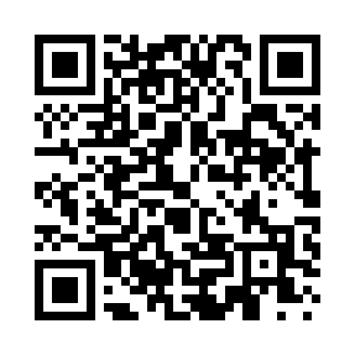
Prayer times for Mexhoma, Oklahoma, USA
Mon 1 Jul 2024 - Wed 31 Jul 2024
High Latitude Method: Angle Based Rule
Prayer Calculation Method: Islamic Society of North America
Asar Calculation Method: Shafi

Date | Day | Fajr | Sunrise | Dhuhr | Asr | Maghrib | Isha
1 | Mon | 5:08 | 6:37 | 1:56 | 5:47 | 9:15 | 10:44
2 | Tue | 5:09 | 6:38 | 1:56 | 5:47 | 9:15 | 10:43
3 | Wed | 5:09 | 6:38 | 1:56 | 5:48 | 9:14 | 10:43
4 | Thu | 5:10 | 6:39 | 1:57 | 5:48 | 9:14 | 10:43
5 | Fri | 5:11 | 6:39 | 1:57 | 5:48 | 9:14 | 10:42
6 | Sat | 5:12 | 6:40 | 1:57 | 5:48 | 9:14 | 10:42
7 | Sun | 5:12 | 6:40 | 1:57 | 5:48 | 9:14 | 10:41
8 | Mon | 5:13 | 6:41 | 1:57 | 5:48 | 9:13 | 10:41
9 | Tue | 5:14 | 6:41 | 1:57 | 5:48 | 9:13 | 10:40
10 | Wed | 5:15 | 6:42 | 1:57 | 5:48 | 9:13 | 10:40
11 | Thu | 5:16 | 6:43 | 1:58 | 5:48 | 9:12 | 10:39
12 | Fri | 5:16 | 6:43 | 1:58 | 5:49 | 9:12 | 10:39
13 | Sat | 5:17 | 6:44 | 1:58 | 5:49 | 9:11 | 10:38
14 | Sun | 5:18 | 6:45 | 1:58 | 5:49 | 9:11 | 10:37
15 | Mon | 5:19 | 6:45 | 1:58 | 5:49 | 9:10 | 10:36
16 | Tue | 5:20 | 6:46 | 1:58 | 5:49 | 9:10 | 10:36
17 | Wed | 5:21 | 6:47 | 1:58 | 5:49 | 9:09 | 10:35
18 | Thu | 5:22 | 6:47 | 1:58 | 5:49 | 9:09 | 10:34
19 | Fri | 5:23 | 6:48 | 1:58 | 5:49 | 9:08 | 10:33
20 | Sat | 5:24 | 6:49 | 1:58 | 5:48 | 9:07 | 10:32
21 | Sun | 5:25 | 6:50 | 1:58 | 5:48 | 9:07 | 10:31
22 | Mon | 5:26 | 6:50 | 1:58 | 5:48 | 9:06 | 10:30
23 | Tue | 5:27 | 6:51 | 1:58 | 5:48 | 9:05 | 10:29
24 | Wed | 5:28 | 6:52 | 1:58 | 5:48 | 9:05 | 10:28
25 | Thu | 5:29 | 6:53 | 1:58 | 5:48 | 9:04 | 10:27
26 | Fri | 5:30 | 6:54 | 1:58 | 5:48 | 9:03 | 10:26
27 | Sat | 5:31 | 6:54 | 1:58 | 5:48 | 9:02 | 10:25
28 | Sun | 5:32 | 6:55 | 1:58 | 5:47 | 9:01 | 10:24
29 | Mon | 5:34 | 6:56 | 1:58 | 5:47 | 9:00 | 10:23
30 | Tue | 5:35 | 6:57 | 1:58 | 5:47 | 9:00 | 10:22
31 | Wed | 5:36 | 6:58 | 1:58 | 5:47 | 8:59 | 10:20
Prayer times provided by https://www.salahtimes.com

