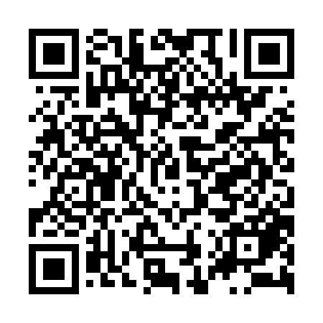
Prayer times for Guantanamo Bay Naval Base, Cuba
Wed 1 May 2024 - Fri 31 May 2024
High Latitude Method: None
Prayer Calculation Method: Muslim World League
Asar Calculation Method: Shafi

Date | Day | Fajr | Sunrise | Dhuhr | Asr | Maghrib | Isha
1 | Wed | 5:14 | 6:31 | 12:58 | 4:16 | 7:24 | 8:38
2 | Thu | 5:13 | 6:31 | 12:58 | 4:15 | 7:25 | 8:38
3 | Fri | 5:12 | 6:30 | 12:58 | 4:15 | 7:25 | 8:39
4 | Sat | 5:11 | 6:30 | 12:58 | 4:14 | 7:26 | 8:39
5 | Sun | 5:11 | 6:29 | 12:57 | 4:14 | 7:26 | 8:40
6 | Mon | 5:10 | 6:29 | 12:57 | 4:14 | 7:26 | 8:40
7 | Tue | 5:09 | 6:28 | 12:57 | 4:13 | 7:27 | 8:41
8 | Wed | 5:09 | 6:28 | 12:57 | 4:13 | 7:27 | 8:42
9 | Thu | 5:08 | 6:27 | 12:57 | 4:12 | 7:27 | 8:42
10 | Fri | 5:07 | 6:27 | 12:57 | 4:12 | 7:28 | 8:43
11 | Sat | 5:07 | 6:26 | 12:57 | 4:12 | 7:28 | 8:43
12 | Sun | 5:06 | 6:26 | 12:57 | 4:11 | 7:29 | 8:44
13 | Mon | 5:05 | 6:25 | 12:57 | 4:11 | 7:29 | 8:44
14 | Tue | 5:05 | 6:25 | 12:57 | 4:11 | 7:29 | 8:45
15 | Wed | 5:04 | 6:25 | 12:57 | 4:10 | 7:30 | 8:45
16 | Thu | 5:04 | 6:24 | 12:57 | 4:10 | 7:30 | 8:46
17 | Fri | 5:03 | 6:24 | 12:57 | 4:10 | 7:31 | 8:47
18 | Sat | 5:03 | 6:24 | 12:57 | 4:10 | 7:31 | 8:47
19 | Sun | 5:02 | 6:23 | 12:57 | 4:10 | 7:31 | 8:48
20 | Mon | 5:02 | 6:23 | 12:57 | 4:10 | 7:32 | 8:48
21 | Tue | 5:02 | 6:23 | 12:57 | 4:11 | 7:32 | 8:49
22 | Wed | 5:01 | 6:23 | 12:58 | 4:12 | 7:33 | 8:49
23 | Thu | 5:01 | 6:22 | 12:58 | 4:12 | 7:33 | 8:50
24 | Fri | 5:00 | 6:22 | 12:58 | 4:13 | 7:34 | 8:50
25 | Sat | 5:00 | 6:22 | 12:58 | 4:13 | 7:34 | 8:51
26 | Sun | 5:00 | 6:22 | 12:58 | 4:14 | 7:34 | 8:51
27 | Mon | 4:59 | 6:22 | 12:58 | 4:14 | 7:35 | 8:52
28 | Tue | 4:59 | 6:21 | 12:58 | 4:15 | 7:35 | 8:53
29 | Wed | 4:59 | 6:21 | 12:58 | 4:16 | 7:36 | 8:53
30 | Thu | 4:59 | 6:21 | 12:58 | 4:16 | 7:36 | 8:54
31 | Fri | 4:58 | 6:21 | 12:59 | 4:17 | 7:36 | 8:54
Prayer times provided by https://www.salahtimes.com

