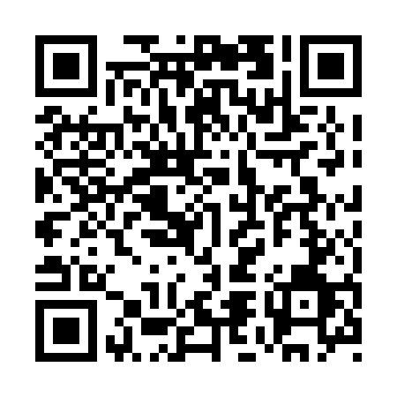
Prayer times for Kirkman Creek, Yukon, Canada
Wed 1 May 2024 - Fri 31 May 2024
High Latitude Method: Angle Based Rule
Prayer Calculation Method: Islamic Society of North America
Asar Calculation Method: Hanafi

Date | Day | Fajr | Sunrise | Dhuhr | Asr | Maghrib | Isha
1 | Wed | 4:05 | 5:55 | 2:15 | 7:38 | 10:36 | 12:25
2 | Thu | 4:04 | 5:52 | 2:14 | 7:39 | 10:39 | 12:27
3 | Fri | 4:02 | 5:49 | 2:14 | 7:41 | 10:42 | 12:28
4 | Sat | 4:00 | 5:46 | 2:14 | 7:42 | 10:45 | 12:30
5 | Sun | 3:59 | 5:42 | 2:14 | 7:44 | 10:47 | 12:31
6 | Mon | 3:57 | 5:39 | 2:14 | 7:46 | 10:50 | 12:33
7 | Tue | 3:55 | 5:36 | 2:14 | 7:47 | 10:53 | 12:34
8 | Wed | 3:54 | 5:33 | 2:14 | 7:49 | 10:56 | 12:36
9 | Thu | 3:52 | 5:30 | 2:14 | 7:50 | 10:59 | 12:37
10 | Fri | 3:51 | 5:27 | 2:14 | 7:52 | 11:02 | 12:39
11 | Sat | 3:49 | 5:24 | 2:14 | 7:53 | 11:05 | 12:40
12 | Sun | 3:48 | 5:21 | 2:14 | 7:55 | 11:08 | 12:41
13 | Mon | 3:46 | 5:18 | 2:14 | 7:56 | 11:11 | 12:43
14 | Tue | 3:45 | 5:15 | 2:14 | 7:58 | 11:14 | 12:44
15 | Wed | 3:43 | 5:12 | 2:14 | 7:59 | 11:17 | 12:46
16 | Thu | 3:42 | 5:09 | 2:14 | 8:00 | 11:20 | 12:47
17 | Fri | 3:41 | 5:06 | 2:14 | 8:02 | 11:23 | 12:49
18 | Sat | 3:39 | 5:04 | 2:14 | 8:03 | 11:26 | 12:50
19 | Sun | 3:38 | 5:01 | 2:14 | 8:05 | 11:29 | 12:52
20 | Mon | 3:36 | 4:58 | 2:14 | 8:06 | 11:32 | 12:53
21 | Tue | 3:35 | 4:55 | 2:14 | 8:07 | 11:34 | 12:55
22 | Wed | 3:34 | 4:53 | 2:14 | 8:08 | 11:37 | 12:56
23 | Thu | 3:33 | 4:50 | 2:14 | 8:10 | 11:40 | 12:57
24 | Fri | 3:31 | 4:48 | 2:14 | 8:11 | 11:43 | 12:59
25 | Sat | 3:30 | 4:45 | 2:15 | 8:12 | 11:45 | 1:00
26 | Sun | 3:29 | 4:43 | 2:15 | 8:13 | 11:48 | 1:02
27 | Mon | 3:28 | 4:40 | 2:15 | 8:14 | 11:51 | 1:03
28 | Tue | 3:27 | 4:38 | 2:15 | 8:15 | 11:53 | 1:04
29 | Wed | 3:26 | 4:36 | 2:15 | 8:16 | 11:56 | 1:06
30 | Thu | 3:25 | 4:34 | 2:15 | 8:17 | 11:58 | 1:07
31 | Fri | 3:24 | 4:31 | 2:15 | 8:18 | 12:00 | 1:08
Prayer times provided by https://www.salahtimes.com

