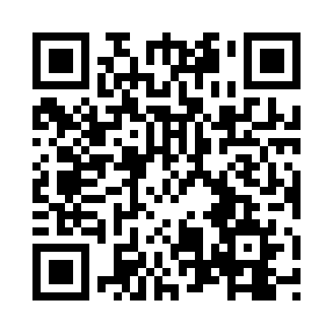
Prayer times for Bilbeis, Egypt
Wed 1 May 2024 - Fri 31 May 2024
High Latitude Method: None
Prayer Calculation Method: Egyptian General Authority of Survey
Asar Calculation Method: Shafi

Date | Day | Fajr | Sunrise | Dhuhr | Asr | Maghrib | Isha
1 | Wed | 4:35 | 6:10 | 12:51 | 4:28 | 7:32 | 8:57
2 | Thu | 4:33 | 6:09 | 12:51 | 4:28 | 7:33 | 8:58
3 | Fri | 4:32 | 6:08 | 12:51 | 4:28 | 7:33 | 8:59
4 | Sat | 4:31 | 6:08 | 12:51 | 4:28 | 7:34 | 9:00
5 | Sun | 4:30 | 6:07 | 12:50 | 4:28 | 7:35 | 9:01
6 | Mon | 4:29 | 6:06 | 12:50 | 4:28 | 7:35 | 9:01
7 | Tue | 4:28 | 6:05 | 12:50 | 4:28 | 7:36 | 9:02
8 | Wed | 4:27 | 6:04 | 12:50 | 4:28 | 7:37 | 9:03
9 | Thu | 4:26 | 6:04 | 12:50 | 4:28 | 7:37 | 9:04
10 | Fri | 4:24 | 6:03 | 12:50 | 4:28 | 7:38 | 9:05
11 | Sat | 4:23 | 6:02 | 12:50 | 4:28 | 7:39 | 9:06
12 | Sun | 4:22 | 6:01 | 12:50 | 4:28 | 7:39 | 9:07
13 | Mon | 4:21 | 6:01 | 12:50 | 4:28 | 7:40 | 9:08
14 | Tue | 4:21 | 6:00 | 12:50 | 4:28 | 7:41 | 9:09
15 | Wed | 4:20 | 5:59 | 12:50 | 4:28 | 7:41 | 9:10
16 | Thu | 4:19 | 5:59 | 12:50 | 4:28 | 7:42 | 9:11
17 | Fri | 4:18 | 5:58 | 12:50 | 4:28 | 7:43 | 9:12
18 | Sat | 4:17 | 5:58 | 12:50 | 4:28 | 7:43 | 9:12
19 | Sun | 4:16 | 5:57 | 12:50 | 4:28 | 7:44 | 9:13
20 | Mon | 4:15 | 5:57 | 12:50 | 4:28 | 7:44 | 9:14
21 | Tue | 4:14 | 5:56 | 12:50 | 4:28 | 7:45 | 9:15
22 | Wed | 4:14 | 5:56 | 12:51 | 4:28 | 7:46 | 9:16
23 | Thu | 4:13 | 5:55 | 12:51 | 4:28 | 7:46 | 9:17
24 | Fri | 4:12 | 5:55 | 12:51 | 4:28 | 7:47 | 9:18
25 | Sat | 4:12 | 5:54 | 12:51 | 4:28 | 7:47 | 9:18
26 | Sun | 4:11 | 5:54 | 12:51 | 4:28 | 7:48 | 9:19
27 | Mon | 4:10 | 5:54 | 12:51 | 4:28 | 7:49 | 9:20
28 | Tue | 4:10 | 5:53 | 12:51 | 4:28 | 7:49 | 9:21
29 | Wed | 4:09 | 5:53 | 12:51 | 4:28 | 7:50 | 9:22
30 | Thu | 4:09 | 5:53 | 12:51 | 4:28 | 7:50 | 9:22
31 | Fri | 4:08 | 5:52 | 12:52 | 4:29 | 7:51 | 9:23
Prayer times provided by https://www.salahtimes.com

