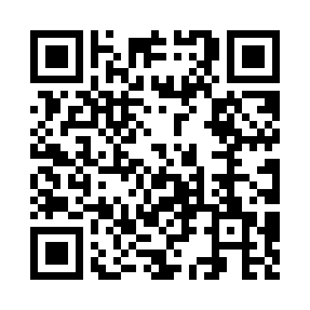
Prayer times for Brushy, Arkansas, USA
Mon 1 Jul 2024 - Wed 31 Jul 2024
High Latitude Method: Angle Based Rule
Prayer Calculation Method: Islamic Society of North America
Asar Calculation Method: Shafi

Date | Day | Fajr | Sunrise | Dhuhr | Asr | Maghrib | Isha
1 | Mon | 4:40 | 6:03 | 1:12 | 4:55 | 8:21 | 9:43
2 | Tue | 4:41 | 6:03 | 1:12 | 4:55 | 8:21 | 9:43
3 | Wed | 4:41 | 6:04 | 1:12 | 4:56 | 8:21 | 9:43
4 | Thu | 4:42 | 6:04 | 1:12 | 4:56 | 8:21 | 9:43
5 | Fri | 4:43 | 6:05 | 1:13 | 4:56 | 8:21 | 9:42
6 | Sat | 4:43 | 6:05 | 1:13 | 4:56 | 8:20 | 9:42
7 | Sun | 4:44 | 6:06 | 1:13 | 4:56 | 8:20 | 9:42
8 | Mon | 4:45 | 6:06 | 1:13 | 4:56 | 8:20 | 9:41
9 | Tue | 4:45 | 6:07 | 1:13 | 4:57 | 8:20 | 9:41
10 | Wed | 4:46 | 6:07 | 1:13 | 4:57 | 8:19 | 9:41
11 | Thu | 4:47 | 6:08 | 1:14 | 4:57 | 8:19 | 9:40
12 | Fri | 4:47 | 6:08 | 1:14 | 4:57 | 8:19 | 9:40
13 | Sat | 4:48 | 6:09 | 1:14 | 4:57 | 8:18 | 9:39
14 | Sun | 4:49 | 6:10 | 1:14 | 4:57 | 8:18 | 9:38
15 | Mon | 4:50 | 6:10 | 1:14 | 4:57 | 8:18 | 9:38
16 | Tue | 4:51 | 6:11 | 1:14 | 4:57 | 8:17 | 9:37
17 | Wed | 4:51 | 6:11 | 1:14 | 4:57 | 8:17 | 9:36
18 | Thu | 4:52 | 6:12 | 1:14 | 4:57 | 8:16 | 9:36
19 | Fri | 4:53 | 6:13 | 1:14 | 4:57 | 8:16 | 9:35
20 | Sat | 4:54 | 6:13 | 1:14 | 4:57 | 8:15 | 9:34
21 | Sun | 4:55 | 6:14 | 1:14 | 4:57 | 8:14 | 9:33
22 | Mon | 4:56 | 6:15 | 1:14 | 4:57 | 8:14 | 9:33
23 | Tue | 4:57 | 6:15 | 1:14 | 4:57 | 8:13 | 9:32
24 | Wed | 4:57 | 6:16 | 1:14 | 4:57 | 8:13 | 9:31
25 | Thu | 4:58 | 6:17 | 1:14 | 4:57 | 8:12 | 9:30
26 | Fri | 4:59 | 6:17 | 1:14 | 4:57 | 8:11 | 9:29
27 | Sat | 5:00 | 6:18 | 1:14 | 4:57 | 8:11 | 9:28
28 | Sun | 5:01 | 6:19 | 1:14 | 4:57 | 8:10 | 9:27
29 | Mon | 5:02 | 6:19 | 1:14 | 4:57 | 8:09 | 9:26
30 | Tue | 5:03 | 6:20 | 1:14 | 4:57 | 8:08 | 9:25
31 | Wed | 5:04 | 6:21 | 1:14 | 4:57 | 8:07 | 9:24
Prayer times provided by https://www.salahtimes.com

