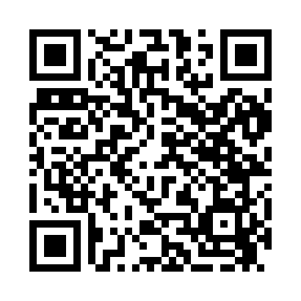
Prayer times for French Lake, Minnesota, USA
Mon 1 Jul 2024 - Wed 31 Jul 2024
High Latitude Method: Angle Based Rule
Prayer Calculation Method: Islamic Society of North America
Asar Calculation Method: Shafi

Date | Day | Fajr | Sunrise | Dhuhr | Asr | Maghrib | Isha
1 | Mon | 3:37 | 5:34 | 1:21 | 5:30 | 9:08 | 11:04
2 | Tue | 3:38 | 5:34 | 1:21 | 5:30 | 9:08 | 11:03
3 | Wed | 3:39 | 5:35 | 1:21 | 5:30 | 9:07 | 11:03
4 | Thu | 3:40 | 5:35 | 1:21 | 5:30 | 9:07 | 11:02
5 | Fri | 3:41 | 5:36 | 1:22 | 5:30 | 9:07 | 11:01
6 | Sat | 3:42 | 5:37 | 1:22 | 5:30 | 9:06 | 11:00
7 | Sun | 3:44 | 5:38 | 1:22 | 5:30 | 9:06 | 10:59
8 | Mon | 3:45 | 5:38 | 1:22 | 5:30 | 9:05 | 10:59
9 | Tue | 3:46 | 5:39 | 1:22 | 5:30 | 9:05 | 10:58
10 | Wed | 3:47 | 5:40 | 1:22 | 5:30 | 9:04 | 10:57
11 | Thu | 3:49 | 5:41 | 1:22 | 5:30 | 9:04 | 10:55
12 | Fri | 3:50 | 5:42 | 1:23 | 5:30 | 9:03 | 10:54
13 | Sat | 3:51 | 5:42 | 1:23 | 5:30 | 9:02 | 10:53
14 | Sun | 3:53 | 5:43 | 1:23 | 5:30 | 9:02 | 10:52
15 | Mon | 3:54 | 5:44 | 1:23 | 5:29 | 9:01 | 10:50
16 | Tue | 3:56 | 5:45 | 1:23 | 5:29 | 9:00 | 10:49
17 | Wed | 3:57 | 5:46 | 1:23 | 5:29 | 8:59 | 10:48
18 | Thu | 3:59 | 5:47 | 1:23 | 5:29 | 8:58 | 10:46
19 | Fri | 4:01 | 5:48 | 1:23 | 5:29 | 8:58 | 10:45
20 | Sat | 4:02 | 5:49 | 1:23 | 5:28 | 8:57 | 10:43
21 | Sun | 4:04 | 5:50 | 1:23 | 5:28 | 8:56 | 10:42
22 | Mon | 4:05 | 5:51 | 1:23 | 5:28 | 8:55 | 10:40
23 | Tue | 4:07 | 5:52 | 1:23 | 5:28 | 8:54 | 10:39
24 | Wed | 4:09 | 5:53 | 1:23 | 5:27 | 8:53 | 10:37
25 | Thu | 4:10 | 5:54 | 1:23 | 5:27 | 8:52 | 10:35
26 | Fri | 4:12 | 5:56 | 1:23 | 5:27 | 8:50 | 10:34
27 | Sat | 4:14 | 5:57 | 1:23 | 5:26 | 8:49 | 10:32
28 | Sun | 4:15 | 5:58 | 1:23 | 5:26 | 8:48 | 10:30
29 | Mon | 4:17 | 5:59 | 1:23 | 5:25 | 8:47 | 10:28
30 | Tue | 4:19 | 6:00 | 1:23 | 5:25 | 8:46 | 10:27
31 | Wed | 4:21 | 6:01 | 1:23 | 5:24 | 8:44 | 10:25
Prayer times provided by https://www.salahtimes.com

