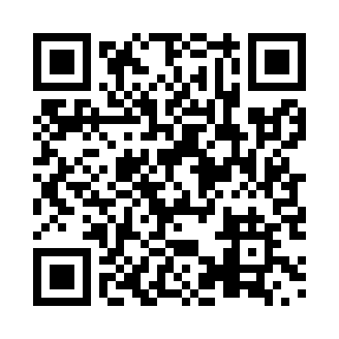
Prayer times for Cloridorme, Quebec, Canada
Wed 1 May 2024 - Fri 31 May 2024
High Latitude Method: Angle Based Rule
Prayer Calculation Method: Islamic Society of North America
Asar Calculation Method: Hanafi

Date | Day | Fajr | Sunrise | Dhuhr | Asr | Maghrib | Isha
1 | Wed | 3:10 | 4:57 | 12:16 | 5:21 | 7:37 | 9:24
2 | Thu | 3:07 | 4:55 | 12:16 | 5:22 | 7:38 | 9:26
3 | Fri | 3:05 | 4:54 | 12:16 | 5:23 | 7:39 | 9:29
4 | Sat | 3:03 | 4:52 | 12:16 | 5:24 | 7:41 | 9:31
5 | Sun | 3:00 | 4:50 | 12:16 | 5:25 | 7:42 | 9:33
6 | Mon | 2:58 | 4:49 | 12:16 | 5:26 | 7:44 | 9:36
7 | Tue | 2:55 | 4:47 | 12:16 | 5:27 | 7:45 | 9:38
8 | Wed | 2:53 | 4:46 | 12:16 | 5:27 | 7:47 | 9:40
9 | Thu | 2:50 | 4:44 | 12:16 | 5:28 | 7:48 | 9:42
10 | Fri | 2:48 | 4:43 | 12:16 | 5:29 | 7:50 | 9:45
11 | Sat | 2:46 | 4:41 | 12:16 | 5:30 | 7:51 | 9:47
12 | Sun | 2:43 | 4:40 | 12:16 | 5:31 | 7:52 | 9:49
13 | Mon | 2:41 | 4:38 | 12:16 | 5:32 | 7:54 | 9:52
14 | Tue | 2:38 | 4:37 | 12:16 | 5:32 | 7:55 | 9:54
15 | Wed | 2:36 | 4:36 | 12:16 | 5:33 | 7:56 | 9:57
16 | Thu | 2:34 | 4:34 | 12:16 | 5:34 | 7:58 | 9:59
17 | Fri | 2:32 | 4:33 | 12:16 | 5:35 | 7:59 | 10:01
18 | Sat | 2:29 | 4:32 | 12:16 | 5:36 | 8:00 | 10:04
19 | Sun | 2:27 | 4:31 | 12:16 | 5:36 | 8:02 | 10:06
20 | Mon | 2:25 | 4:29 | 12:16 | 5:37 | 8:03 | 10:08
21 | Tue | 2:23 | 4:28 | 12:16 | 5:38 | 8:04 | 10:10
22 | Wed | 2:22 | 4:27 | 12:16 | 5:39 | 8:05 | 10:11
23 | Thu | 2:21 | 4:26 | 12:16 | 5:39 | 8:07 | 10:12
24 | Fri | 2:21 | 4:25 | 12:16 | 5:40 | 8:08 | 10:12
25 | Sat | 2:20 | 4:24 | 12:16 | 5:41 | 8:09 | 10:13
26 | Sun | 2:20 | 4:23 | 12:16 | 5:41 | 8:10 | 10:13
27 | Mon | 2:20 | 4:22 | 12:17 | 5:42 | 8:11 | 10:14
28 | Tue | 2:19 | 4:22 | 12:17 | 5:43 | 8:12 | 10:15
29 | Wed | 2:19 | 4:21 | 12:17 | 5:43 | 8:13 | 10:15
30 | Thu | 2:19 | 4:20 | 12:17 | 5:44 | 8:15 | 10:16
31 | Fri | 2:18 | 4:19 | 12:17 | 5:45 | 8:16 | 10:16
Prayer times provided by https://www.salahtimes.com

