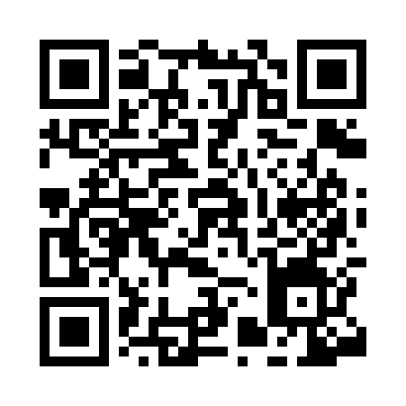
Prayer times for Albergo, Italy
Wed 1 May 2024 - Fri 31 May 2024
High Latitude Method: Angle Based Rule
Prayer Calculation Method: Muslim World League
Asar Calculation Method: Hanafi

Date | Day | Fajr | Sunrise | Dhuhr | Asr | Maghrib | Isha
1 | Wed | 4:14 | 5:55 | 12:51 | 5:45 | 7:47 | 9:22
2 | Thu | 4:12 | 5:54 | 12:51 | 5:45 | 7:48 | 9:24
3 | Fri | 4:10 | 5:53 | 12:51 | 5:46 | 7:49 | 9:25
4 | Sat | 4:09 | 5:52 | 12:51 | 5:46 | 7:50 | 9:26
5 | Sun | 4:07 | 5:51 | 12:50 | 5:47 | 7:51 | 9:28
6 | Mon | 4:06 | 5:50 | 12:50 | 5:47 | 7:52 | 9:29
7 | Tue | 4:04 | 5:48 | 12:50 | 5:48 | 7:53 | 9:31
8 | Wed | 4:03 | 5:47 | 12:50 | 5:49 | 7:54 | 9:32
9 | Thu | 4:01 | 5:46 | 12:50 | 5:49 | 7:55 | 9:33
10 | Fri | 4:00 | 5:45 | 12:50 | 5:50 | 7:56 | 9:35
11 | Sat | 3:58 | 5:44 | 12:50 | 5:50 | 7:57 | 9:36
12 | Sun | 3:57 | 5:43 | 12:50 | 5:51 | 7:57 | 9:37
13 | Mon | 3:55 | 5:42 | 12:50 | 5:51 | 7:58 | 9:39
14 | Tue | 3:54 | 5:41 | 12:50 | 5:52 | 7:59 | 9:40
15 | Wed | 3:52 | 5:41 | 12:50 | 5:52 | 8:00 | 9:41
16 | Thu | 3:51 | 5:40 | 12:50 | 5:53 | 8:01 | 9:43
17 | Fri | 3:50 | 5:39 | 12:50 | 5:53 | 8:02 | 9:44
18 | Sat | 3:49 | 5:38 | 12:50 | 5:54 | 8:03 | 9:45
19 | Sun | 3:47 | 5:37 | 12:50 | 5:54 | 8:04 | 9:47
20 | Mon | 3:46 | 5:37 | 12:50 | 5:55 | 8:05 | 9:48
21 | Tue | 3:45 | 5:36 | 12:50 | 5:55 | 8:05 | 9:49
22 | Wed | 3:44 | 5:35 | 12:51 | 5:56 | 8:06 | 9:50
23 | Thu | 3:43 | 5:34 | 12:51 | 5:56 | 8:07 | 9:52
24 | Fri | 3:41 | 5:34 | 12:51 | 5:57 | 8:08 | 9:53
25 | Sat | 3:40 | 5:33 | 12:51 | 5:57 | 8:09 | 9:54
26 | Sun | 3:39 | 5:33 | 12:51 | 5:57 | 8:10 | 9:55
27 | Mon | 3:38 | 5:32 | 12:51 | 5:58 | 8:10 | 9:56
28 | Tue | 3:37 | 5:32 | 12:51 | 5:58 | 8:11 | 9:58
29 | Wed | 3:37 | 5:31 | 12:51 | 5:59 | 8:12 | 9:59
30 | Thu | 3:36 | 5:31 | 12:51 | 5:59 | 8:13 | 10:00
31 | Fri | 3:35 | 5:30 | 12:52 | 6:00 | 8:13 | 10:01
Prayer times provided by https://www.salahtimes.com

