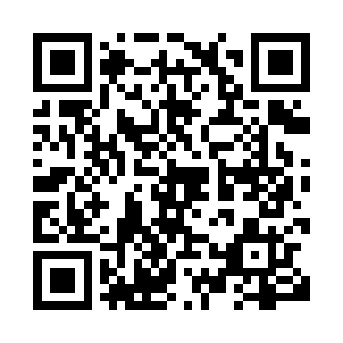
Prayer times for Ukkusikallak, Quebec, Canada
Wed 1 May 2024 - Fri 31 May 2024
High Latitude Method: Angle Based Rule
Prayer Calculation Method: Islamic Society of North America
Asar Calculation Method: Hanafi

Date | Day | Fajr | Sunrise | Dhuhr | Asr | Maghrib | Isha
1 | Wed | 3:12 | 5:20 | 1:03 | 6:16 | 8:48 | 10:56
2 | Thu | 3:11 | 5:18 | 1:03 | 6:18 | 8:50 | 10:57
3 | Fri | 3:10 | 5:16 | 1:03 | 6:19 | 8:52 | 10:58
4 | Sat | 3:09 | 5:14 | 1:03 | 6:20 | 8:54 | 10:59
5 | Sun | 3:08 | 5:11 | 1:03 | 6:21 | 8:56 | 11:00
6 | Mon | 3:06 | 5:09 | 1:03 | 6:22 | 8:58 | 11:01
7 | Tue | 3:05 | 5:07 | 1:03 | 6:24 | 9:00 | 11:02
8 | Wed | 3:04 | 5:05 | 1:03 | 6:25 | 9:02 | 11:03
9 | Thu | 3:03 | 5:03 | 1:03 | 6:26 | 9:04 | 11:03
10 | Fri | 3:02 | 5:01 | 1:03 | 6:27 | 9:06 | 11:04
11 | Sat | 3:01 | 4:59 | 1:03 | 6:28 | 9:08 | 11:05
12 | Sun | 3:00 | 4:57 | 1:03 | 6:29 | 9:09 | 11:06
13 | Mon | 2:59 | 4:55 | 1:03 | 6:30 | 9:11 | 11:07
14 | Tue | 2:58 | 4:53 | 1:03 | 6:31 | 9:13 | 11:08
15 | Wed | 2:57 | 4:51 | 1:03 | 6:33 | 9:15 | 11:09
16 | Thu | 2:56 | 4:50 | 1:03 | 6:34 | 9:17 | 11:10
17 | Fri | 2:56 | 4:48 | 1:03 | 6:35 | 9:19 | 11:11
18 | Sat | 2:55 | 4:46 | 1:03 | 6:36 | 9:21 | 11:12
19 | Sun | 2:54 | 4:44 | 1:03 | 6:37 | 9:22 | 11:13
20 | Mon | 2:53 | 4:43 | 1:03 | 6:38 | 9:24 | 11:14
21 | Tue | 2:52 | 4:41 | 1:03 | 6:39 | 9:26 | 11:15
22 | Wed | 2:52 | 4:40 | 1:03 | 6:40 | 9:28 | 11:16
23 | Thu | 2:51 | 4:38 | 1:03 | 6:41 | 9:29 | 11:16
24 | Fri | 2:50 | 4:36 | 1:03 | 6:41 | 9:31 | 11:17
25 | Sat | 2:49 | 4:35 | 1:03 | 6:42 | 9:33 | 11:18
26 | Sun | 2:49 | 4:34 | 1:04 | 6:43 | 9:34 | 11:19
27 | Mon | 2:48 | 4:32 | 1:04 | 6:44 | 9:36 | 11:20
28 | Tue | 2:48 | 4:31 | 1:04 | 6:45 | 9:37 | 11:21
29 | Wed | 2:47 | 4:30 | 1:04 | 6:46 | 9:39 | 11:21
30 | Thu | 2:47 | 4:29 | 1:04 | 6:47 | 9:40 | 11:22
31 | Fri | 2:46 | 4:28 | 1:04 | 6:47 | 9:41 | 11:23
Prayer times provided by https://www.salahtimes.com

