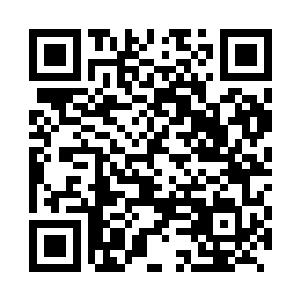
Prayer times for Barwa, Cameroon
Mon 1 Apr 2024 - Tue 30 Apr 2024
High Latitude Method: None
Prayer Calculation Method: Muslim World League
Asar Calculation Method: Shafi

Date | Day | Fajr | Sunrise | Dhuhr | Asr | Maghrib | Isha
1 | Mon | 4:59 | 6:09 | 12:15 | 3:22 | 6:21 | 7:27
2 | Tue | 4:58 | 6:08 | 12:14 | 3:21 | 6:21 | 7:27
3 | Wed | 4:58 | 6:08 | 12:14 | 3:20 | 6:21 | 7:26
4 | Thu | 4:57 | 6:07 | 12:14 | 3:19 | 6:21 | 7:26
5 | Fri | 4:57 | 6:07 | 12:14 | 3:18 | 6:21 | 7:26
6 | Sat | 4:56 | 6:06 | 12:13 | 3:17 | 6:20 | 7:26
7 | Sun | 4:55 | 6:06 | 12:13 | 3:17 | 6:20 | 7:26
8 | Mon | 4:55 | 6:05 | 12:13 | 3:16 | 6:20 | 7:26
9 | Tue | 4:54 | 6:05 | 12:12 | 3:15 | 6:20 | 7:27
10 | Wed | 4:54 | 6:04 | 12:12 | 3:14 | 6:20 | 7:27
11 | Thu | 4:53 | 6:04 | 12:12 | 3:15 | 6:20 | 7:27
12 | Fri | 4:53 | 6:03 | 12:12 | 3:15 | 6:20 | 7:27
13 | Sat | 4:52 | 6:03 | 12:11 | 3:16 | 6:20 | 7:27
14 | Sun | 4:52 | 6:02 | 12:11 | 3:16 | 6:20 | 7:27
15 | Mon | 4:51 | 6:02 | 12:11 | 3:17 | 6:20 | 7:27
16 | Tue | 4:50 | 6:01 | 12:11 | 3:17 | 6:20 | 7:27
17 | Wed | 4:50 | 6:01 | 12:10 | 3:18 | 6:20 | 7:27
18 | Thu | 4:49 | 6:00 | 12:10 | 3:18 | 6:20 | 7:27
19 | Fri | 4:49 | 6:00 | 12:10 | 3:19 | 6:20 | 7:27
20 | Sat | 4:48 | 6:00 | 12:10 | 3:19 | 6:20 | 7:27
21 | Sun | 4:48 | 5:59 | 12:10 | 3:20 | 6:20 | 7:27
22 | Mon | 4:47 | 5:59 | 12:09 | 3:20 | 6:20 | 7:27
23 | Tue | 4:47 | 5:58 | 12:09 | 3:21 | 6:20 | 7:28
24 | Wed | 4:46 | 5:58 | 12:09 | 3:21 | 6:20 | 7:28
25 | Thu | 4:46 | 5:58 | 12:09 | 3:22 | 6:20 | 7:28
26 | Fri | 4:45 | 5:57 | 12:09 | 3:22 | 6:20 | 7:28
27 | Sat | 4:45 | 5:57 | 12:09 | 3:22 | 6:20 | 7:28
28 | Sun | 4:44 | 5:57 | 12:08 | 3:23 | 6:20 | 7:28
29 | Mon | 4:44 | 5:56 | 12:08 | 3:23 | 6:20 | 7:28
30 | Tue | 4:43 | 5:56 | 12:08 | 3:24 | 6:20 | 7:29
Prayer times provided by https://www.salahtimes.com

