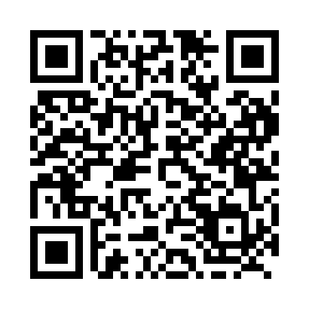
Prayer times for Akulivik, Quebec, Canada
Wed 1 May 2024 - Fri 31 May 2024
High Latitude Method: Angle Based Rule
Prayer Calculation Method: Islamic Society of North America
Asar Calculation Method: Hanafi

Date | Day | Fajr | Sunrise | Dhuhr | Asr | Maghrib | Isha
1 | Wed | 3:07 | 5:04 | 1:10 | 6:29 | 9:17 | 11:14
2 | Thu | 3:06 | 5:02 | 1:10 | 6:31 | 9:19 | 11:15
3 | Fri | 3:05 | 4:59 | 1:10 | 6:32 | 9:22 | 11:16
4 | Sat | 3:03 | 4:56 | 1:10 | 6:34 | 9:24 | 11:17
5 | Sun | 3:02 | 4:53 | 1:09 | 6:35 | 9:27 | 11:19
6 | Mon | 3:00 | 4:51 | 1:09 | 6:36 | 9:30 | 11:20
7 | Tue | 2:59 | 4:48 | 1:09 | 6:38 | 9:32 | 11:21
8 | Wed | 2:58 | 4:45 | 1:09 | 6:39 | 9:35 | 11:22
9 | Thu | 2:56 | 4:43 | 1:09 | 6:41 | 9:37 | 11:24
10 | Fri | 2:55 | 4:40 | 1:09 | 6:42 | 9:40 | 11:25
11 | Sat | 2:54 | 4:37 | 1:09 | 6:43 | 9:42 | 11:26
12 | Sun | 2:52 | 4:35 | 1:09 | 6:45 | 9:45 | 11:27
13 | Mon | 2:51 | 4:32 | 1:09 | 6:46 | 9:47 | 11:29
14 | Tue | 2:50 | 4:30 | 1:09 | 6:47 | 9:50 | 11:30
15 | Wed | 2:49 | 4:27 | 1:09 | 6:49 | 9:52 | 11:31
16 | Thu | 2:47 | 4:25 | 1:09 | 6:50 | 9:55 | 11:32
17 | Fri | 2:46 | 4:22 | 1:09 | 6:51 | 9:57 | 11:34
18 | Sat | 2:45 | 4:20 | 1:09 | 6:52 | 10:00 | 11:35
19 | Sun | 2:44 | 4:18 | 1:09 | 6:54 | 10:02 | 11:36
20 | Mon | 2:43 | 4:16 | 1:09 | 6:55 | 10:04 | 11:37
21 | Tue | 2:42 | 4:13 | 1:09 | 6:56 | 10:07 | 11:38
22 | Wed | 2:41 | 4:11 | 1:10 | 6:57 | 10:09 | 11:40
23 | Thu | 2:40 | 4:09 | 1:10 | 6:58 | 10:11 | 11:41
24 | Fri | 2:39 | 4:07 | 1:10 | 6:59 | 10:13 | 11:42
25 | Sat | 2:38 | 4:05 | 1:10 | 7:00 | 10:16 | 11:43
26 | Sun | 2:37 | 4:03 | 1:10 | 7:02 | 10:18 | 11:44
27 | Mon | 2:36 | 4:01 | 1:10 | 7:03 | 10:20 | 11:45
28 | Tue | 2:35 | 3:59 | 1:10 | 7:04 | 10:22 | 11:46
29 | Wed | 2:34 | 3:58 | 1:10 | 7:05 | 10:24 | 11:47
30 | Thu | 2:33 | 3:56 | 1:10 | 7:06 | 10:26 | 11:48
31 | Fri | 2:33 | 3:54 | 1:11 | 7:06 | 10:28 | 11:49
Prayer times provided by https://www.salahtimes.com

