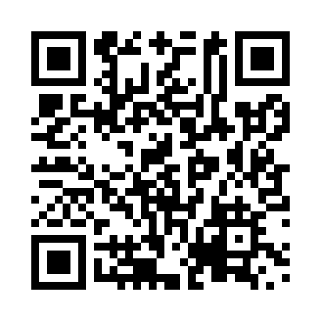
Prayer times for Tolstoi, Manitoba, Canada
Sat 1 Jun 2024 - Sun 30 Jun 2024
High Latitude Method: Angle Based Rule
Prayer Calculation Method: Islamic Society of North America
Asar Calculation Method: Hanafi

Date | Day | Fajr | Sunrise | Dhuhr | Asr | Maghrib | Isha
1 | Sat | 3:26 | 5:27 | 1:25 | 6:53 | 9:24 | 11:25
2 | Sun | 3:26 | 5:26 | 1:25 | 6:54 | 9:25 | 11:25
3 | Mon | 3:26 | 5:26 | 1:26 | 6:54 | 9:26 | 11:26
4 | Tue | 3:25 | 5:25 | 1:26 | 6:55 | 9:27 | 11:26
5 | Wed | 3:25 | 5:25 | 1:26 | 6:55 | 9:28 | 11:27
6 | Thu | 3:25 | 5:24 | 1:26 | 6:56 | 9:28 | 11:27
7 | Fri | 3:25 | 5:24 | 1:26 | 6:56 | 9:29 | 11:28
8 | Sat | 3:25 | 5:23 | 1:26 | 6:57 | 9:30 | 11:28
9 | Sun | 3:25 | 5:23 | 1:27 | 6:57 | 9:31 | 11:29
10 | Mon | 3:25 | 5:23 | 1:27 | 6:58 | 9:31 | 11:29
11 | Tue | 3:25 | 5:23 | 1:27 | 6:58 | 9:32 | 11:30
12 | Wed | 3:25 | 5:22 | 1:27 | 6:58 | 9:32 | 11:30
13 | Thu | 3:25 | 5:22 | 1:27 | 6:59 | 9:33 | 11:30
14 | Fri | 3:25 | 5:22 | 1:28 | 6:59 | 9:33 | 11:31
15 | Sat | 3:25 | 5:22 | 1:28 | 7:00 | 9:34 | 11:31
16 | Sun | 3:25 | 5:22 | 1:28 | 7:00 | 9:34 | 11:31
17 | Mon | 3:25 | 5:22 | 1:28 | 7:00 | 9:35 | 11:32
18 | Tue | 3:25 | 5:22 | 1:29 | 7:00 | 9:35 | 11:32
19 | Wed | 3:26 | 5:22 | 1:29 | 7:01 | 9:35 | 11:32
20 | Thu | 3:26 | 5:23 | 1:29 | 7:01 | 9:36 | 11:32
21 | Fri | 3:26 | 5:23 | 1:29 | 7:01 | 9:36 | 11:32
22 | Sat | 3:26 | 5:23 | 1:29 | 7:01 | 9:36 | 11:33
23 | Sun | 3:26 | 5:23 | 1:30 | 7:01 | 9:36 | 11:33
24 | Mon | 3:27 | 5:24 | 1:30 | 7:02 | 9:36 | 11:33
25 | Tue | 3:27 | 5:24 | 1:30 | 7:02 | 9:36 | 11:33
26 | Wed | 3:27 | 5:25 | 1:30 | 7:02 | 9:36 | 11:33
27 | Thu | 3:28 | 5:25 | 1:31 | 7:02 | 9:36 | 11:33
28 | Fri | 3:28 | 5:26 | 1:31 | 7:02 | 9:36 | 11:33
29 | Sat | 3:28 | 5:26 | 1:31 | 7:02 | 9:36 | 11:33
30 | Sun | 3:29 | 5:27 | 1:31 | 7:02 | 9:35 | 11:33
Prayer times provided by https://www.salahtimes.com

