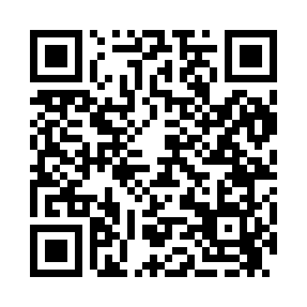
Prayer times for Brownsville, Texas, USA
Wed 1 May 2024 - Fri 31 May 2024
High Latitude Method: Angle Based Rule
Prayer Calculation Method: Islamic Society of North America
Asar Calculation Method: Shafi

Date | Day | Fajr | Sunrise | Dhuhr | Asr | Maghrib | Isha
1 | Wed | 5:45 | 6:52 | 1:27 | 4:57 | 8:02 | 9:10
2 | Thu | 5:44 | 6:52 | 1:27 | 4:57 | 8:02 | 9:10
3 | Fri | 5:43 | 6:51 | 1:27 | 4:56 | 8:03 | 9:11
4 | Sat | 5:42 | 6:50 | 1:27 | 4:56 | 8:03 | 9:12
5 | Sun | 5:41 | 6:50 | 1:27 | 4:56 | 8:04 | 9:12
6 | Mon | 5:40 | 6:49 | 1:27 | 4:56 | 8:04 | 9:13
7 | Tue | 5:40 | 6:48 | 1:26 | 4:56 | 8:05 | 9:14
8 | Wed | 5:39 | 6:48 | 1:26 | 4:55 | 8:05 | 9:14
9 | Thu | 5:38 | 6:47 | 1:26 | 4:55 | 8:06 | 9:15
10 | Fri | 5:37 | 6:46 | 1:26 | 4:55 | 8:07 | 9:16
11 | Sat | 5:36 | 6:46 | 1:26 | 4:55 | 8:07 | 9:17
12 | Sun | 5:36 | 6:45 | 1:26 | 4:55 | 8:08 | 9:17
13 | Mon | 5:35 | 6:45 | 1:26 | 4:55 | 8:08 | 9:18
14 | Tue | 5:34 | 6:44 | 1:26 | 4:54 | 8:09 | 9:19
15 | Wed | 5:34 | 6:44 | 1:26 | 4:54 | 8:09 | 9:19
16 | Thu | 5:33 | 6:43 | 1:26 | 4:54 | 8:10 | 9:20
17 | Fri | 5:32 | 6:43 | 1:26 | 4:54 | 8:10 | 9:21
18 | Sat | 5:32 | 6:42 | 1:26 | 4:54 | 8:11 | 9:22
19 | Sun | 5:31 | 6:42 | 1:26 | 4:54 | 8:11 | 9:22
20 | Mon | 5:31 | 6:41 | 1:27 | 4:54 | 8:12 | 9:23
21 | Tue | 5:30 | 6:41 | 1:27 | 4:54 | 8:12 | 9:24
22 | Wed | 5:29 | 6:41 | 1:27 | 4:54 | 8:13 | 9:24
23 | Thu | 5:29 | 6:40 | 1:27 | 4:54 | 8:13 | 9:25
24 | Fri | 5:28 | 6:40 | 1:27 | 4:54 | 8:14 | 9:26
25 | Sat | 5:28 | 6:40 | 1:27 | 4:54 | 8:14 | 9:26
26 | Sun | 5:28 | 6:39 | 1:27 | 4:54 | 8:15 | 9:27
27 | Mon | 5:27 | 6:39 | 1:27 | 4:54 | 8:15 | 9:27
28 | Tue | 5:27 | 6:39 | 1:27 | 4:54 | 8:16 | 9:28
29 | Wed | 5:26 | 6:39 | 1:27 | 4:54 | 8:16 | 9:29
30 | Thu | 5:26 | 6:38 | 1:28 | 4:54 | 8:17 | 9:29
31 | Fri | 5:26 | 6:38 | 1:28 | 4:54 | 8:17 | 9:30
Prayer times provided by https://www.salahtimes.com

