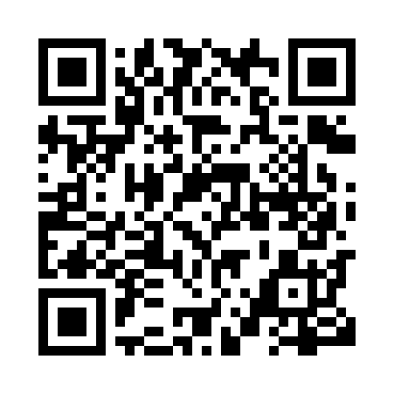
Prayer times for Toniata, Manitoba, Canada
Mon 1 Apr 2024 - Tue 30 Apr 2024
High Latitude Method: Angle Based Rule
Prayer Calculation Method: Islamic Society of North America
Asar Calculation Method: Hanafi

Date | Day | Fajr | Sunrise | Dhuhr | Asr | Maghrib | Isha
1 | Mon | 5:24 | 6:56 | 1:25 | 5:53 | 7:54 | 9:26
2 | Tue | 5:22 | 6:54 | 1:24 | 5:54 | 7:55 | 9:28
3 | Wed | 5:19 | 6:52 | 1:24 | 5:55 | 7:57 | 9:30
4 | Thu | 5:17 | 6:50 | 1:24 | 5:56 | 7:58 | 9:32
5 | Fri | 5:14 | 6:48 | 1:23 | 5:57 | 8:00 | 9:34
6 | Sat | 5:12 | 6:46 | 1:23 | 5:58 | 8:01 | 9:36
7 | Sun | 5:09 | 6:44 | 1:23 | 5:59 | 8:03 | 9:38
8 | Mon | 5:07 | 6:42 | 1:23 | 6:01 | 8:04 | 9:40
9 | Tue | 5:04 | 6:40 | 1:22 | 6:02 | 8:06 | 9:42
10 | Wed | 5:02 | 6:37 | 1:22 | 6:03 | 8:08 | 9:44
11 | Thu | 4:59 | 6:35 | 1:22 | 6:04 | 8:09 | 9:46
12 | Fri | 4:57 | 6:33 | 1:22 | 6:05 | 8:11 | 9:48
13 | Sat | 4:54 | 6:31 | 1:21 | 6:06 | 8:12 | 9:50
14 | Sun | 4:52 | 6:29 | 1:21 | 6:07 | 8:14 | 9:52
15 | Mon | 4:49 | 6:27 | 1:21 | 6:08 | 8:15 | 9:54
16 | Tue | 4:46 | 6:25 | 1:21 | 6:09 | 8:17 | 9:56
17 | Wed | 4:44 | 6:23 | 1:20 | 6:10 | 8:18 | 9:58
18 | Thu | 4:41 | 6:21 | 1:20 | 6:11 | 8:20 | 10:00
19 | Fri | 4:39 | 6:19 | 1:20 | 6:12 | 8:21 | 10:02
20 | Sat | 4:36 | 6:17 | 1:20 | 6:13 | 8:23 | 10:05
21 | Sun | 4:34 | 6:15 | 1:19 | 6:14 | 8:25 | 10:07
22 | Mon | 4:31 | 6:13 | 1:19 | 6:15 | 8:26 | 10:09
23 | Tue | 4:28 | 6:11 | 1:19 | 6:16 | 8:28 | 10:11
24 | Wed | 4:26 | 6:10 | 1:19 | 6:17 | 8:29 | 10:13
25 | Thu | 4:23 | 6:08 | 1:19 | 6:18 | 8:31 | 10:16
26 | Fri | 4:21 | 6:06 | 1:19 | 6:19 | 8:32 | 10:18
27 | Sat | 4:18 | 6:04 | 1:18 | 6:20 | 8:34 | 10:20
28 | Sun | 4:16 | 6:02 | 1:18 | 6:21 | 8:35 | 10:22
29 | Mon | 4:13 | 6:00 | 1:18 | 6:22 | 8:37 | 10:25
30 | Tue | 4:10 | 5:59 | 1:18 | 6:23 | 8:38 | 10:27
Prayer times provided by https://www.salahtimes.com

