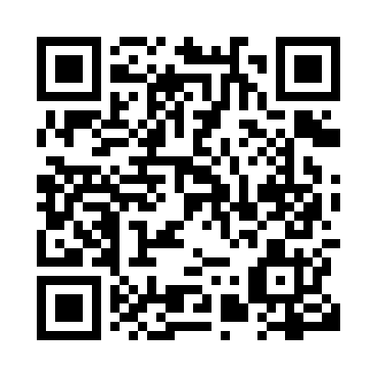
Prayer times for MacRae, Yukon, Canada
Wed 1 May 2024 - Fri 31 May 2024
High Latitude Method: Angle Based Rule
Prayer Calculation Method: Islamic Society of North America
Asar Calculation Method: Hanafi

Date | Day | Fajr | Sunrise | Dhuhr | Asr | Maghrib | Isha
1 | Wed | 3:55 | 5:52 | 1:57 | 7:16 | 10:03 | 12:00
2 | Thu | 3:53 | 5:49 | 1:57 | 7:18 | 10:06 | 12:02
3 | Fri | 3:52 | 5:47 | 1:57 | 7:19 | 10:08 | 12:03
4 | Sat | 3:51 | 5:44 | 1:57 | 7:21 | 10:11 | 12:04
5 | Sun | 3:49 | 5:41 | 1:57 | 7:22 | 10:14 | 12:05
6 | Mon | 3:48 | 5:38 | 1:57 | 7:24 | 10:16 | 12:07
7 | Tue | 3:46 | 5:36 | 1:57 | 7:25 | 10:19 | 12:08
8 | Wed | 3:45 | 5:33 | 1:56 | 7:26 | 10:21 | 12:09
9 | Thu | 3:44 | 5:30 | 1:56 | 7:28 | 10:24 | 12:10
10 | Fri | 3:42 | 5:28 | 1:56 | 7:29 | 10:26 | 12:12
11 | Sat | 3:41 | 5:25 | 1:56 | 7:30 | 10:29 | 12:13
12 | Sun | 3:40 | 5:23 | 1:56 | 7:32 | 10:31 | 12:14
13 | Mon | 3:39 | 5:20 | 1:56 | 7:33 | 10:34 | 12:15
14 | Tue | 3:37 | 5:18 | 1:56 | 7:34 | 10:36 | 12:17
15 | Wed | 3:36 | 5:15 | 1:56 | 7:36 | 10:39 | 12:18
16 | Thu | 3:35 | 5:13 | 1:56 | 7:37 | 10:41 | 12:19
17 | Fri | 3:34 | 5:11 | 1:56 | 7:38 | 10:43 | 12:20
18 | Sat | 3:33 | 5:08 | 1:56 | 7:39 | 10:46 | 12:21
19 | Sun | 3:32 | 5:06 | 1:57 | 7:41 | 10:48 | 12:23
20 | Mon | 3:31 | 5:04 | 1:57 | 7:42 | 10:50 | 12:24
21 | Tue | 3:29 | 5:02 | 1:57 | 7:43 | 10:53 | 12:25
22 | Wed | 3:28 | 5:00 | 1:57 | 7:44 | 10:55 | 12:26
23 | Thu | 3:27 | 4:57 | 1:57 | 7:45 | 10:57 | 12:27
24 | Fri | 3:26 | 4:55 | 1:57 | 7:46 | 10:59 | 12:28
25 | Sat | 3:26 | 4:53 | 1:57 | 7:47 | 11:02 | 12:30
26 | Sun | 3:25 | 4:52 | 1:57 | 7:48 | 11:04 | 12:31
27 | Mon | 3:24 | 4:50 | 1:57 | 7:49 | 11:06 | 12:32
28 | Tue | 3:23 | 4:48 | 1:57 | 7:50 | 11:08 | 12:33
29 | Wed | 3:22 | 4:46 | 1:58 | 7:51 | 11:10 | 12:34
30 | Thu | 3:21 | 4:45 | 1:58 | 7:52 | 11:12 | 12:35
31 | Fri | 3:21 | 4:43 | 1:58 | 7:53 | 11:14 | 12:36
Prayer times provided by https://www.salahtimes.com

